BHFL

MARKETING

BRD

CUSTOMER APP

UI / UX OPTIMISATIONS

**Document details**

|  |  |  |  |  |
| --- | --- | --- | --- | --- |
| **Version** | **Date** | **Created by** | **Reviewed by** | **Approved by** |
| 1.1 | 23.11.24 | Abanti Chattopadhyay | Cyna Bhathena | Neel Shah |
|  |  |  |  |  |
|  |  |  |  |  |
|  |  |  |  |  |

INTRODUCTION 4

SCOPING 4

FIGMA 4

SCREEN-WISE JOURNEY CHANGES 5

1. Pre-login > Splash 5

2. Pre-Login > App T&C and Permissions 5

3. Pre-Login Screen 9

4. Login Screens 11

**STATES:** 12

4.A. Login > Registered Mobile Number/Email ID 12

4.B. Login > Customer ID (CIF) 16

4.C. Login > mPIN 19

5.Home 22

5.A. Home > Quick Links 27

5.B. Home > Docked Footer 29

6. Loan Details 36

6.A. Loan Details > EMI Details 37

6.B. Loan Details > Tenor Details 38

6.C. Loan Details > Loan Details 38

6.D. Loan Details > Statements & Documents 39

6.F. Loan Details > Increase My EMI 44

6.G. Loan Details > Top-up Loan Entry Way 49

7. Online Payment 51

7.A. Online Payment > Loan Details Screen > ‘Pay Now’ 51

7.B. Online Payment > Pay EMI & Other Overdues 54

7.C. Online Payment > Part-Prepayment 60

**STATES:** 60

7.D. Online Payment > Pay Advance EMIs 66

8. Menu 68

8.A. Menu > Help & Support 70

8.B. Menu > Help & Support > Support Services for You 74

STANDARDISATION OF COMMON ELEMENTS 77

9. Pop-ups 77

9.A. Pop-up > OTP Pop-up 79

10. Key Component Highlights 80

## INTRODUCTION

This document details the entire App project, including change suggestions from a User Interface and User Experience point of view – detailed through instructions herein, Figma screens in the provided links, and element/component-level behaviour changes (if and where applicable).

## SCOPING

As part of this project, all of the user journeys within the Customer App have been reviewed for optimisation.

The scope for these optimisations extends to:

1. Content shown on the front-end
2. Design elements, such as banners and icons
3. Page design/layout (shown through Figma)
4. User journeys – scenario-wise redirections / validations
5. Component behaviour – what is clickable/interactable

All suggestions have been detailed in the subsequent sections journey-wise, screen-wise as Old vs. New – for easy comprehension. Each screen/journey’s Old vs. New detailing includes changes in 3 sections – UI, Content, Behaviour.

## FIGMA

The below Figma link is the master reference point for all changes; it details the:

1. The suggested user journeys with relevant states
2. The revised content (Content in the final development MUST be as per the Figma)
3. Content mapping for screens that are **adapts, error states, and dynamic scrolls** have been provided in the BRD
4. For journeys such as **Flexi Loans, My Offers, Our Product Offerings, VAS, My Profile, Service Request History, Device Security,** and **eKYC,** the Figma only includes UI and Content level changes; the journeys should continue as they are in the existing build
5. Content for **‘FAQs’** screens and the **‘Support Services for You’** journeys will be finalised by the UAT stage

**IMP:** In some cases, where the screen has no change, the existing frame’s screenshot has been included and the same has been called out. **Therefore, the Figma is intended to be an all-encompassing resource for all journeys. If any screens, journeys are missed here, please call out the same. In case nothing is flagged, it is assumed that the App contains no other screens apart from those detailed in the Figma.**

<https://www.figma.com/design/UNKKqN2vO4FPymCfkp2lll/BHFL--App---DEV?node-id=0-1&node-type=canvas&t=7QtGCpXQo0IXBIAb-0>

# SCREEN-WISE JOURNEY CHANGES

# 1. Pre-login > Splash

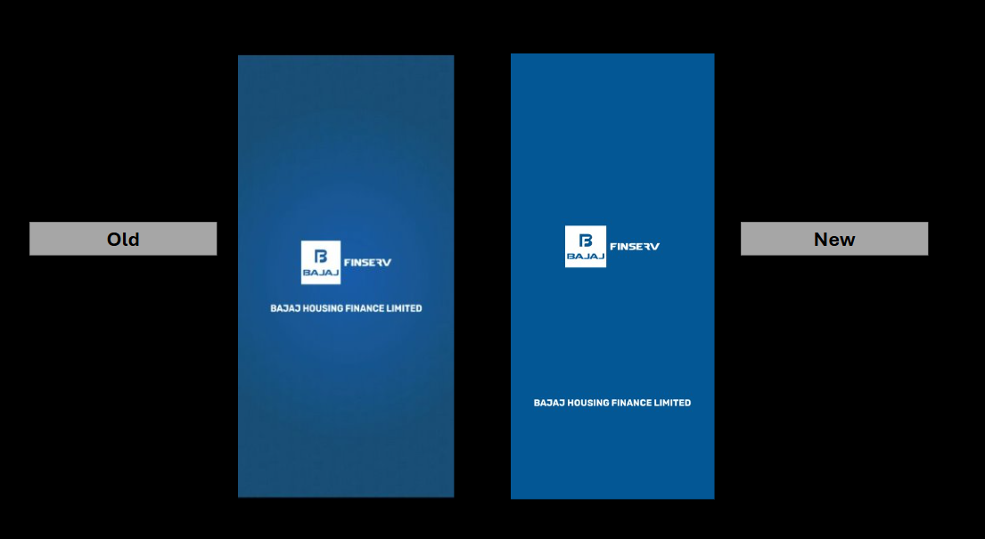

1. The logo placements have been revised
2. Additional UI changes have been made, such as colours, as shown in the Figma; please develop exactly as is on the Figma

# 2. Pre-Login > App T&C and Permissions

At present, whenever a new user downloads the mobile app, they’re shown a launch screen that requests the required permissions. We now need to update that screen. Please update content, hyperlinks, and UI changes as per the Figma:

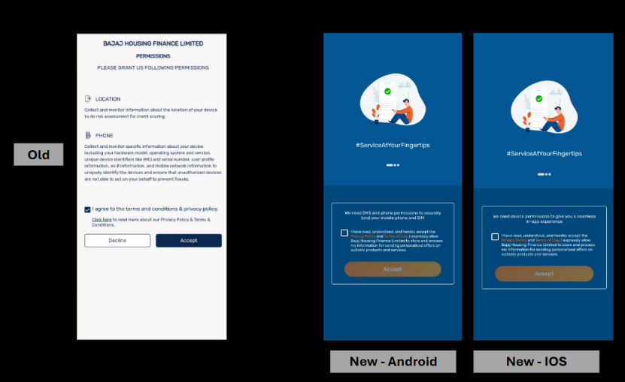

Overall, the *entire screen has been redesigned* from a UI, Content, and Behavior perspective; please update exactly as per Figma and the notes detailed below:

1. A slide-able **‘vector graphic + content unit’** has been added to top-half of the screen; assets included in the Figma/File
2. The slide-able unit should automatically change, wherein, the **‘vector graphic + content unit’** should auto-slide after every **5 seconds**

**NOTE: Only the ‘vector graphic + content unit’ is scrollable; the content unit stays static as it is still one screen:**

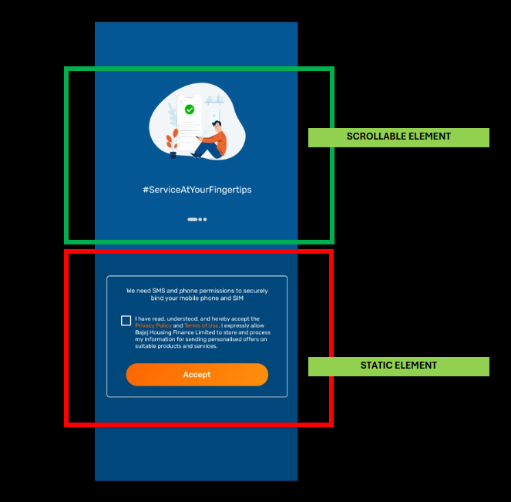

1. The default state has been given in the Figma; however, below is the scroll-wise mapping of the content and graphic element – please update the same basis the standardisation in the Figma:

|  |  |  |
| --- | --- | --- |
| **Vector graphic + content unit name** | **Content on the Screen** | **File name for image on the scroll** |
| Scroll One | #ServiceAtYourFingertips | Pre-Login Vector File Name: 1 |
| Scroll two | Adjust repayment, download documents, and do much more | Pre-Login Vector File Name: 2 |
| Scroll three | Make payments, and grab customised offers, on the go | Pre-Login Vector File Name: 3 |

1. The content for the entire screen has been updated; please update as per the Figma
2. The phrases ‘Privacy Policy’ and ‘Terms of Use’ should be hyperlinked with the following URLs:

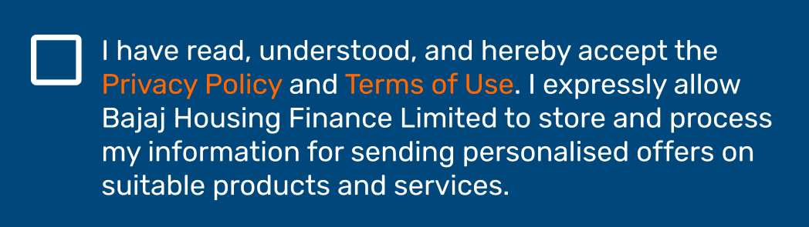

|  |  |  |
| --- | --- | --- |
| **PHRASE** | **URL** | **Remarks** |
| Privacy Policy | https://www.bajajhousingfinance.in/documents/37350/180943/PRIVACY_TERMS.pdf | PDF to open in App Environment |
| Terms of Use | https://www.bajajhousingfinance.in/documents/37350/180943/terms_of_use.pdf | PDF to open in App Environment |

1. An additional state has been provided with the bio-metric authentication for standardisation; whenever the fingerprint authentication is live, the same can be used
2. This entire screen should be visible only to those users who are downloading and **launching the app for the first time, on an Android Device and IOS device**
3. *CTA behaviour:* The **‘Accept’ CTA** should be enabled only after the user selects the checkbox

Similar to the new screen designed above, for the Android Devices, we will require a second state for **IOS devices.** As such, there is **NO DIFFERENCE** in the two states, from a UI and behavior perspective; so the same should be mirrored for this state. However, there is a minor copy difference:

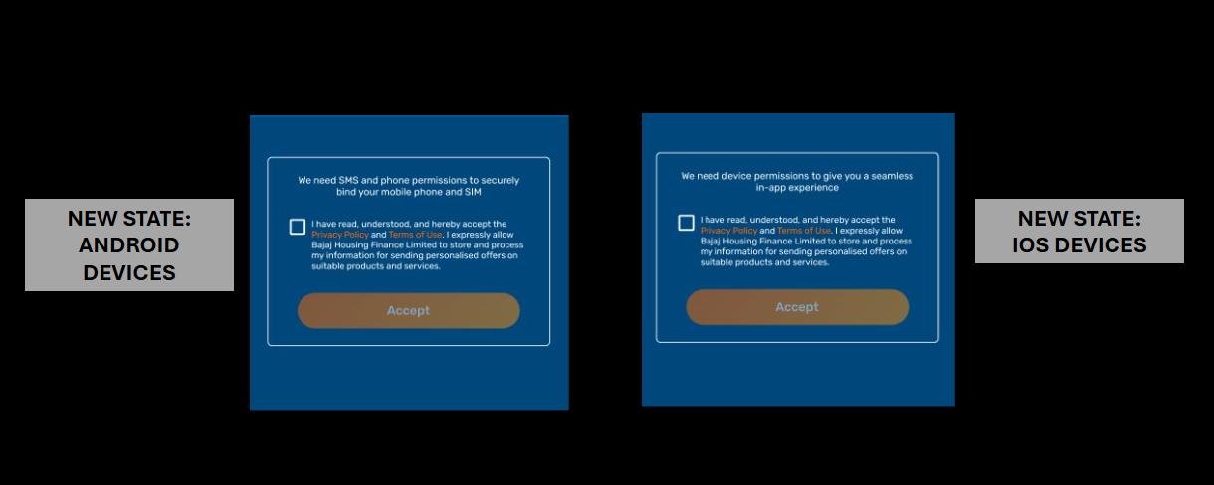

1. Content change: Content for the IOS state has been provided in the Figma; please update as is

# 3. Pre-Login Screen

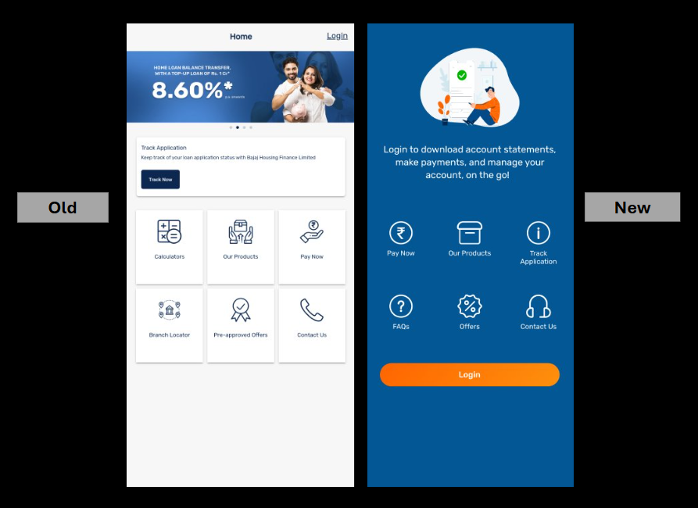The pre-login screen has been updated from a UI and content perspective; however, the behavior of the components remains largly the same, i.e., each clickable icon/tile should redirect the user to a different destination:

1. Remove the head strip
2. Remove the banner scroll
3. Remove the **Track Application** component
4. Replace all the above with the image component + text box (***this stays static – no sliding element needed here)***, as shown in Figma
5. 06 icon tray needed, with 01 CTA at the bottom
6. Behavior**:** Each element, that is the text+icon set, must be clickable
7. Behavior**:** Just as each ‘text+icon’ set is clickable, the user is either redirected to a new screen, or a pop-up should appear on top of the existing screen:

|  |  |  |  |
| --- | --- | --- | --- |
| **image component + text box** | **Redirection – Y/N** | **Screen that should appear next** | **URL, if needed** |
| Pay now | YES – outside the App | (same as existing journey) | https://myaccount.bajajhousingfinance.in/#/payments/paynow |
| Our Products | YES – to a new screen on app | (same as existing journey) |  |
| Track Application | YES – outside the App | (same as existing journey) | https://myaccount.bajajhousingfinance.in/#/tracker/tracker-home |
| FAQs | NO | Pre-Login>FAQs > Pre-Login |  |
| Offers | NO | (same as existing journey) | Link for terms & conditions hyperlink text: <https://www.bajajhousingfinance.in/documents/37350/180943/terms_of_use.pdf> |
| Contact Us | NO – a pop-up should appear on top of the existing screen | Contact Us (Pre-Login) |  |

1. Behavior**:** When the user clicks **‘Contact Us’,** they should be redirected as detailed:

|  |  |
| --- | --- |
| **Clickable component** | **Component Behavior** |
| **Call Us** | The user’s mobile phone dialer should appear, with the phone number **‘020-45297300’** pre-populated |
| **Email Us** | The user’s device’s default email application should open with a new email draft, with the email ID [‘bhflwecare@bajajfinserv.in’](mailto:‘bhflwecare@bajajfinserv.in’) prepopulated in the recipient section |
| **Find Us** | Upon selection, the user should be redirected to the **Branch Locator (Pre-Login)** journey, as shown in the Figma |

1. Behavior**:** The **‘Login’** CTA at the bottom must be clickable
2. Redirection: When the user clicks **‘Login’**, they should be redirected to the **‘Login with Mobile Number/Email ID’** login state

# 4. Login Screens

At present, there are three options available for the user to login in the app *(including only what is visible on the App file shared*):

* Customer can login using their registered Mobile Number/Email-ID, followed by the OTP – *this should be treated as the default option*
* Customer can login using Customer-ID (CIF) and password
* Customers can login using their MPIN (mobile pin)

**Note for common element**: the **‘headphone’** icon at the left-hand-side-corner of every screen has been retained. Upon tapping, a pop-up should appear on top of whatever native screen the user is on. **The background should have a translucent overlay, on top of which the pop-up should appear:**

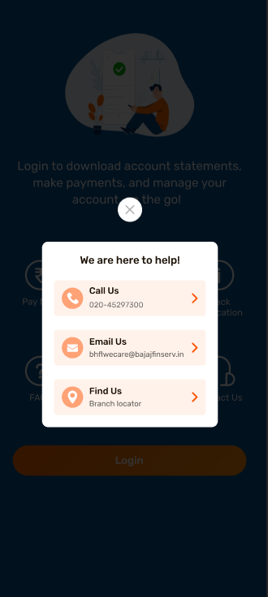

### **STATES:**

### 4.A. Login > Registered Mobile Number/Email ID

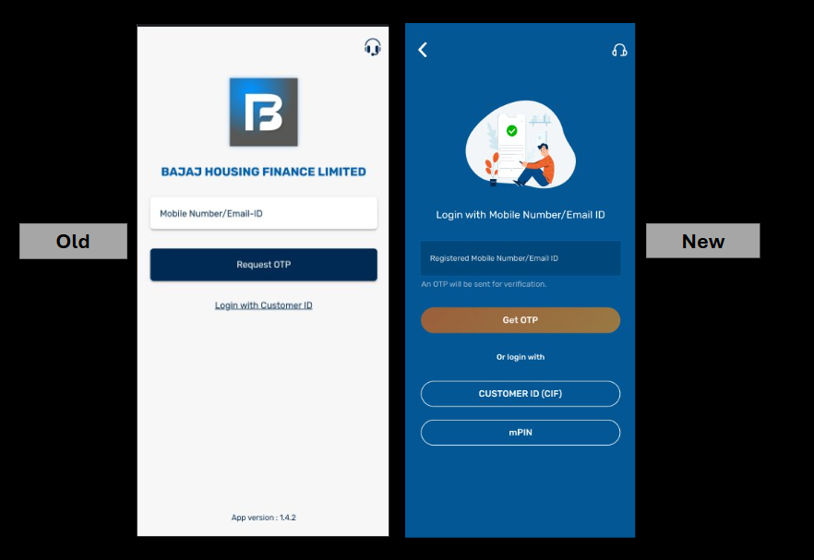

1. Old Logos to be replaced by the splash image
2. Copy to be added under the splash image
3. The ‘Registered Mobile Number/Email ID’ field should have an in-field text:

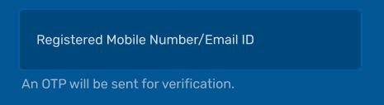

1. If the user inserts the wrong information in the field, they should be shown an **error message**, as shown in the Figma. This should appear after the user clicks on **‘Get OTP’:**

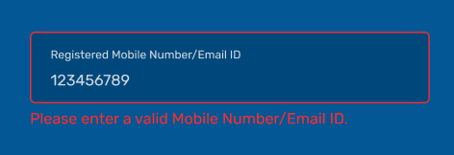

1. Below are the error scenarios that can occur for the **‘Registered Mobile Number/Email ID’** field:

|  |  |  |  |
| --- | --- | --- | --- |
| **Field Name** | **Event** | **Trigger** | **Error Message** |
| Registered Mobile Number/Email ID | Incorrect Mobile Number entered | ‘Get OTP’ CTA selected | Please enter a valid Mobile Number/Email ID. |

1. **‘Get OTP’** CTA to be updated as per the standardised CTA treatment provided in the Figma
2. Remove the text that has been hyperlinked: **‘Login with Customer ID’:**

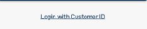

1. Add new content under the **‘Get OTP’** CTA: **‘Or login with’**
2. New elements: Need to add two new CTAs should be added, as shown in the Figma:

* CUSTOMER ID (CIF) - should take the user to the **‘Customer ID (CIF)’** state
* mPIN – should take the user to the **‘mPIN’** state

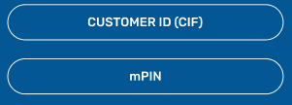

1. CTA Behavior: No change in behaviour from the existing screens, i.e., the **‘Get OTP’** CTA should be enabled only after the required field has been filled in
2. Behavior: After the user inserts the **correct** mobile number/emailer address in Field 1 and selects **‘Get OTP’,** the OTP drawer should appear from the bottom of the screen, as shown in the Figma:

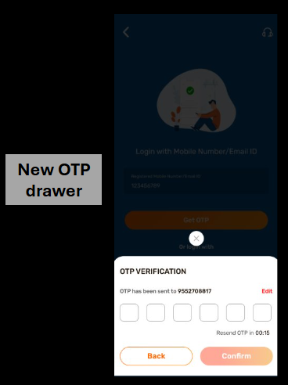

1. Behavior: User has the option to **‘Edit’** the provided mobile number/email address; if the user selects ‘Edit’, they should be re-routed to the main state again
2. Behavior: Similarly, if the user selects the **‘Back’** CTA or the **‘x’ cross element**, the pop-up drawer should be removed to reveal the screen behind
3. Behavior: The **‘Confirm’** CTA is enabled only after the full **6-digit OTP** is entered, and if the ‘Revised OTP’ timer is between **02:59 and 00.01 minutes**
4. Upon success, the user should land on the ‘**Post-Login State: Home’**
5. Error states: There are a **few errors scenarios** that the user can encounter in this state; basis the sample screen provided here, and the template in the Figma, please update the content in the demarcated space for each scenario:

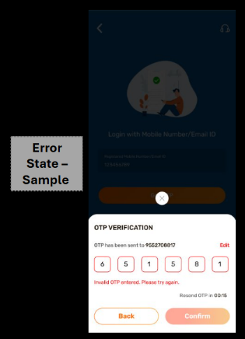

|  |  |  |  |  |  |
| --- | --- | --- | --- | --- | --- |
| Event | Trigger | Duration | Error Message | ‘Resend OTP’ behavior | ‘Get OTP’ behavior |
| OTP entered is incorrect | ‘Get OTP’ CTA clicked | N/A | **Invalid OTP entered. Please try again.** | Should be enabled after error prompt | To be enabled after all 6 digits have been typed in, in under 3 minutes |
| OTP has special characters | ‘Get OTP’ CTA clicked | N/A | **Invalid OTP entered. Please try again.** | Should be enabled after error prompt | To be enabled after all 6 digits have been typed in, in under 3 minutes |
| OTP has timed out – but no value has been inserted in the field | OTP timer has run out | 3 minutes | **OTP expired. Please generate a new OTP.** | Should be enabled after 3 minutes | Disabled |
| OTP entered after timer is out | OTP timer has run out | 3 minutes | **OTP expired. Please generate a new OTP.** | Should be enabled after 3 minutes | Disabled |
| OTP entered but CTA not clicked | OTP timer has run out | 3 minutes | **OTP expired. Please generate a new OTP.** | Should be enabled after 3 minutes | Disabled |
| OTP not received | OTP timer has run out | 3 minutes | **N/A** | Should be enabled after error prompt | Disabled |
| App tech issue | Should be auto identified |  | **We are facing technical errors. Please try again shortly.** | N/A | N/A |

### 4.B. Login > Customer ID (CIF)

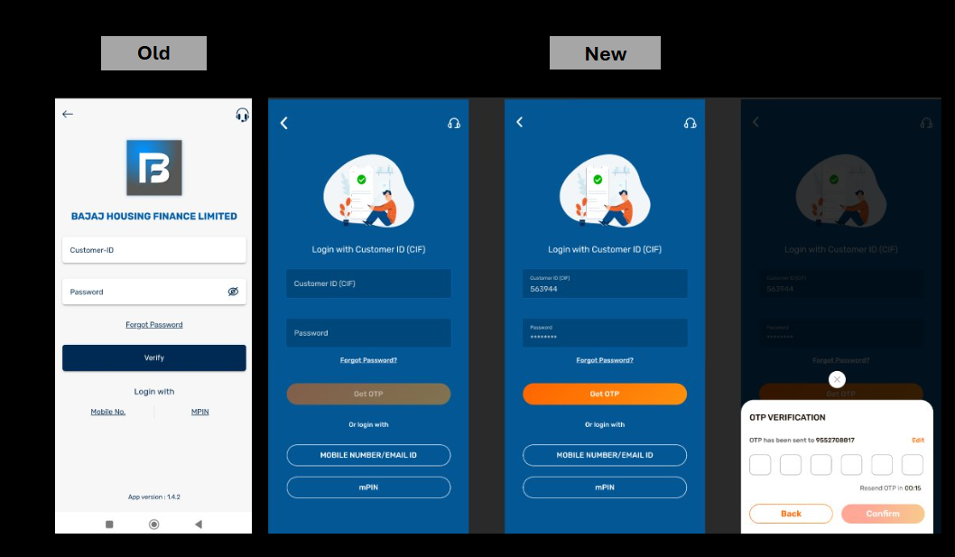

1. Old Logos to be replaced by the splash image
2. Copy to be added under the splash image, as shown in the Figma
3. **‘Forgot Password’** component to redirect as per the existing journey as on the portal:

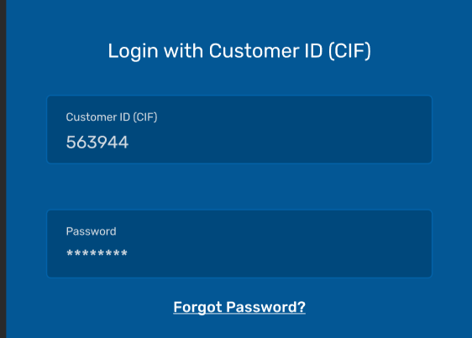

1. If the user inserts the **wrong ‘Customer ID (CIF)’** in the field, they should be shown an **error message**, as shown in the Figma. This should appear after the user clicks on **‘Verify’:**

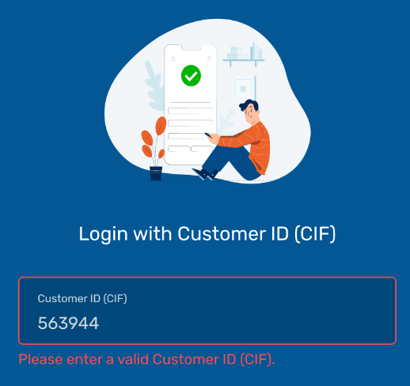

1. If the user inserts the incomplete **‘Customer ID (CIF)’, i.e., under 6 digits** in the field, they should be shown an **error message**, as shown in the Figma. This should appear after the user clicks on **‘Get OTP’.**

Error text to be as written: Invalid entry. **Please enter the 6-digit Customer ID (CIF).**

1. If the user inserts the wrong password in the ‘Password’ field, they should be shown an **error message**, as shown in the Figma. This should appear after the user clicks on **‘Get OTP:**

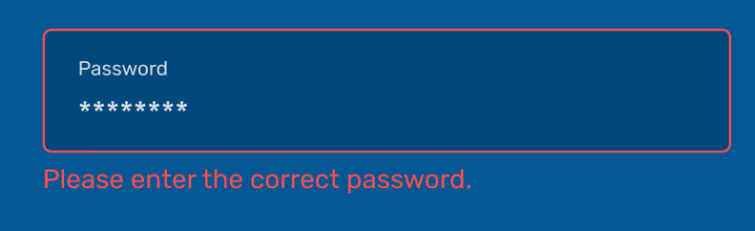

1. **‘Get OTP’** CTA to be updated as per the standardised CTA treatment provided in the Figma
2. Remove the texts that have been hyperlinked **‘Mobile Number’** and **‘MPIN’:**

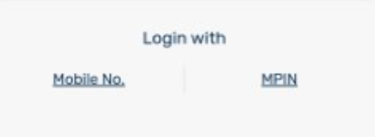

1. Add new content under the **‘Get OTP’** CTA: **‘Or login with’**
2. New elements: Need to add two new CTAs should be added, as shown in the Figma:

* MOBILE NUMBER/EMAIL ID - should take the user to the **‘Mobile Number/Email ID’** state
* mPIN – should take the user to the **‘mPIN’** state

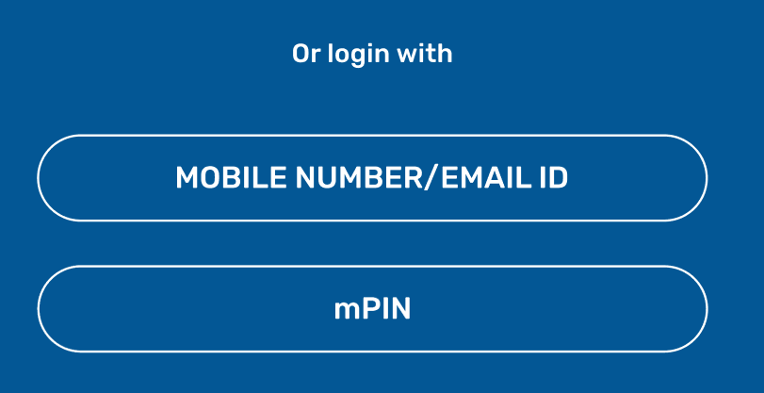

1. Journey Completion with MFA: Once the user clicks on **‘Get OTP’, the OTP pop-up drawer** should appear on the screen. Upon success, the user should land on the **‘Post-Login State: Home’**

### 4.C. Login > mPIN

If the user selects ‘mPIN’ as their login option, and have not set their mPINs, they should be shown the pop-up.

1. The pop-up drawer has to be recreated and standardised as per the pop-up drawers in the Figma:

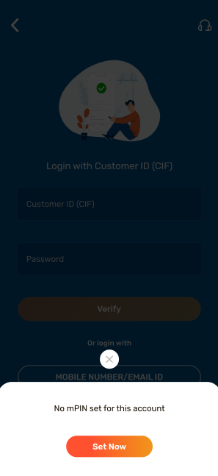

1. If the user clicks on **‘Set Now’** they should be redirected to the **‘Use M-PIN Code’** journey, that already exists in the app, under **‘Device Security’**:

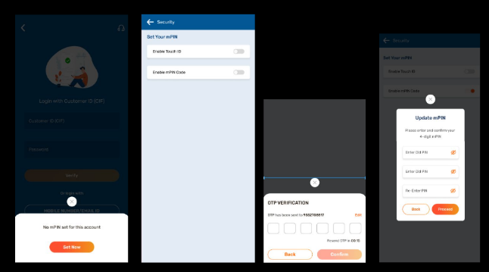

1. If the user already has an existing mPIN, their journey should be as follows:

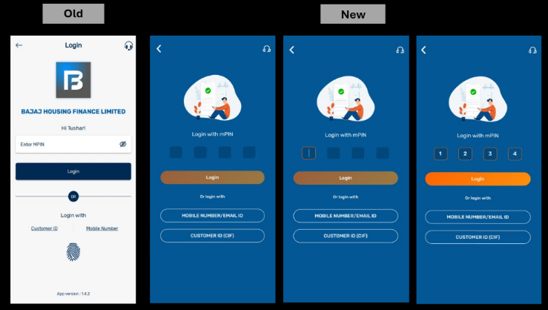

1. Old logos to be replaced by the splash image
2. Remove name customisation - **‘Hi Tushar**!’
3. Content to be added under the splash image: Login with mPIN
4. The field treatment (one box for one digit) should be updated as per the Figma
5. **‘Login’** CTA to be updated as per the standardised CTA treatment provided in the Figma
6. Remove the password visibility toggle (eye icon)
7. In each mPIN box, the digit should be visible to the user – should not be masked
8. Remove the line separator
9. Remove the the texts that have been hyperlinked **‘Mobile Number’** and **‘Customer ID’:**

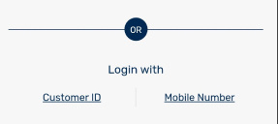

1. Add new content under the **‘Login’** CTA: **‘Or login with’**
2. New elements: Need to add two new CTAs should be added, as shown in the Figma:

* MOBILE NUMBER/EMAIL ID - should take the user to the **‘Mobile Number/Email ID’** state
* CUSTOMER ID (CIF) – should take the user to the **‘Customer ID (CIF)’** state

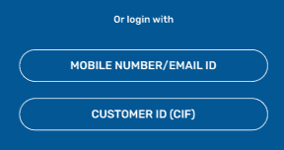

1. **‘Forgot mPIN?’** option has also been added to this screen; As no screens have been shared with for this journey, please replicate the current journey as is.

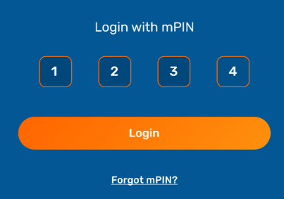

1. CTA behaviour: the ‘Login’ CTA should be enabled only after all four digits have been filled into the field
2. If the user inserts the **wrong ‘mPIN’** in the field, they should be shown an **error message**, as shown in the Figma. This should appear after the user clicks on **‘Login’:**

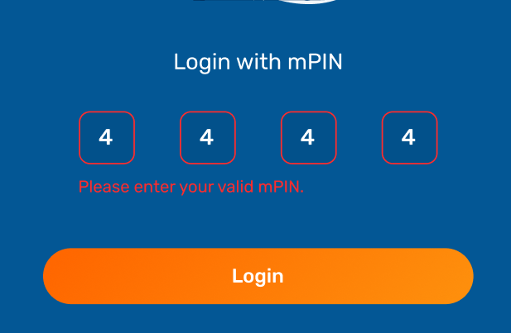

1. If the user does not fill in all four digits of the mPIN, the CTA button should not be activated
2. Upon success, the user should land on the ‘Post-Login State: Home’

# 5.Home

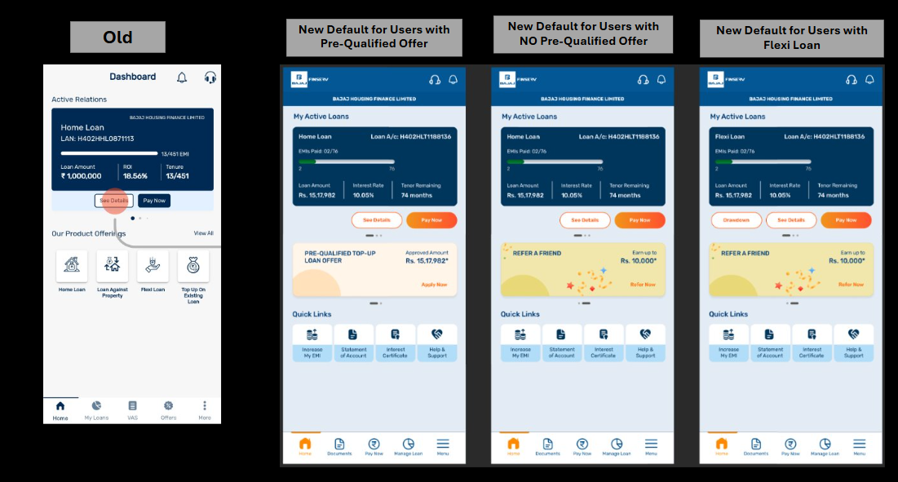

Overall, all main functionalities on this screen have been retained or just optimised. While there are **two key new builds here,** the behavior for components such as the **upper most loan card/s, CTAs, ‘Our Product Offerings’ ‘Pre-Approved Offer’ banner scroll’** largely remain the same. Please update all UI, Content level changes basis the screens and journeys mapped in the Figma:

1. The existing ‘Dashboard’ top-strip is replaced by a header (please include every element present in the header, as shown in the Figma
2. Header behavior: In the header, only the ‘headphone’ icon at the left-hand-side-corner should be clickable. Upon clicking, the pop-up should appear on top of the existing screen. **The background should have a translucent overlay, on top of which the pop-up should appear.**
3. Content change: Update ‘Active Relations’ to **‘My Active Loans’**
4. The blue loan card only has content level changes, and UI alignment changes; please update as per the Figma. **There is no change in the logic that governs the ‘EMIs Paid’ slider.**

e) There should be two CTAs under the blue loan card

* See Details
* Pay Now
* Drawdown: **should be visible only to those users who have a flexi loan mapped against their LAN; this data should fetched as per the existing logic**

1. Please update the CTAs below the blue loan card, to be standardised as per the Figma.
2. There is no change in the CTA behavior for **‘See Details’** and **‘Drawdown’;** User should be redirected to the same screens, as the existing logic on the App
3. At present, the **Blue Loan Card** component has been made scrollable/slide-able, wherein, if the user has more than **Active Loan, its subsequent cards are displayed upon sliding – this should be retained**
4. If the user has a **closed loan** along with an **active loan,** a **grey card** containing all the details for the existing ‘Closed Loans’ card should be displayed upon scrolling:

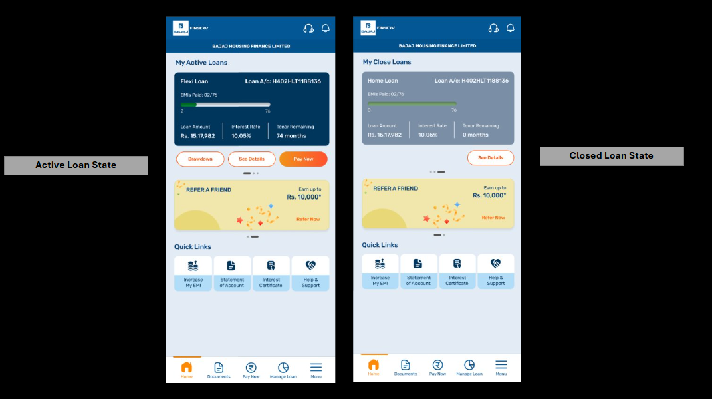

* If the Loan Card is **blue (as per Figma), the Loan Account is active**
* If the Loan Card is **grey (as per Figma), the Loan account is closed**
* If the user has a Closed Loan, then upon swiping, the page title should also change from ‘**My Active Loans’ to ‘My Closed Loans’**

**Note:** We have no screens for a scenario where the user’s only loan account is closed.

1. The redirection for the **‘Pay Now’** CTA however, has to be changed; if the user clicks on ‘Pay Now’, they should be redirected to the ‘**Online Payments**’ landing page:

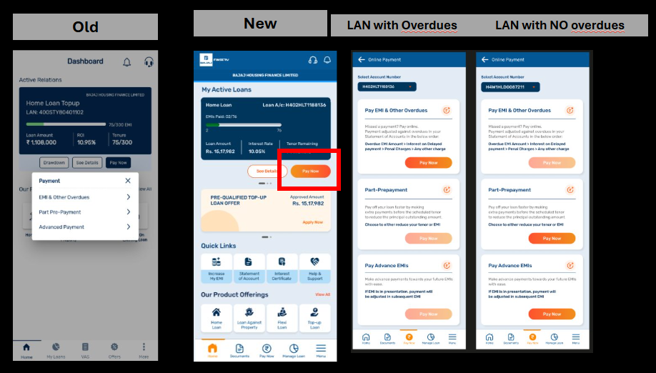

1. The **‘Select Account Number’** should be prepopulated with the selected LAN from the Blue Loan Card
2. State Behavior: **If the LAN has overdues,** the ‘Pay Now’ CTAs in ‘Part-Prepayment’ and ‘Pay Advance EMIs’ Card CTAs should be disabled with only the ‘Pay Now’ CTA in the ‘Pay EMIs & Other Overdues’ enabled
3. State Behavior: **If the LAN has no overdues,** the ‘Pay Now’ CTAs in the ‘Part-Prepayment’ and ‘Pay Advance EMIs’ Cards should be enabled
4. There is already an existing placement for banners in the app; the same should be optimised to showcase the following, basis user-scenarios:

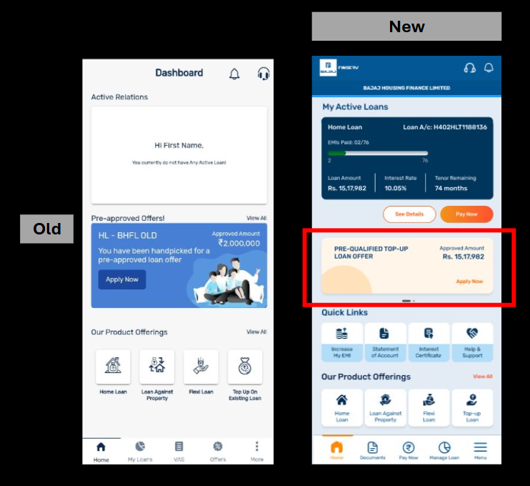

|  |  |  |  |
| --- | --- | --- | --- |
| User-scenario | Banner Orders | Count of Banners | Redirection |
| LAN with Pre-Qualified Offer | 1. Pre-Qualified Banner 2. Refer a Friend Banner | 2 in total | Should open on the **‘My Offers’** screen, with the **‘Top-up Loan’** tile highlighted, under the **‘Request a Customer Offer’** component. Please update as per Figma  Note that as the user already has an offer, the same offer amount should be **prepopulated in the ‘Loan Amount Field’** |
| LAN with no Pre-Qualified Offer | 1. Refer a Friend Banner | 1 in total | To redirect to the BHFL website, on the ‘Customer Referral Program’ page: <https://www.bajajhousingfinance.in/customer-referral-program>  Behavior: The user should ideally be placed on the ‘Referrer Details’ Blue Form, upon landing on the page.  Note: The ‘Referrer Details’ form should already be pre-filled, basis the information available against the user’s profile. SSO efforts to be discussed with IT |

1. Component Build: There should be **no limitation on the count of banners t**hat this component can have**, that auto-slides (if applicable) after 7 seconds.**

**However, note that as of now, we are suggesting a banner set of two.**

1. If the user clicks on **‘View All’**, the redirection should be the same as the existing logic, on the App
2. Remove the existing **‘Our Product Offerings’** tray from this screen:

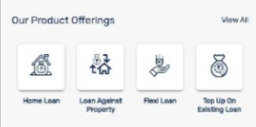

### 5.A. Home > Quick Links

The **‘Quick Links’** component is a new build on the **‘Home’** screen. The purpose of this element is to make the Home screen of the app more customised to the users’ needs, basis the quantum and nature of service requests/key propositions. The build is such that the user can reach the selected destination in just a few clicks.

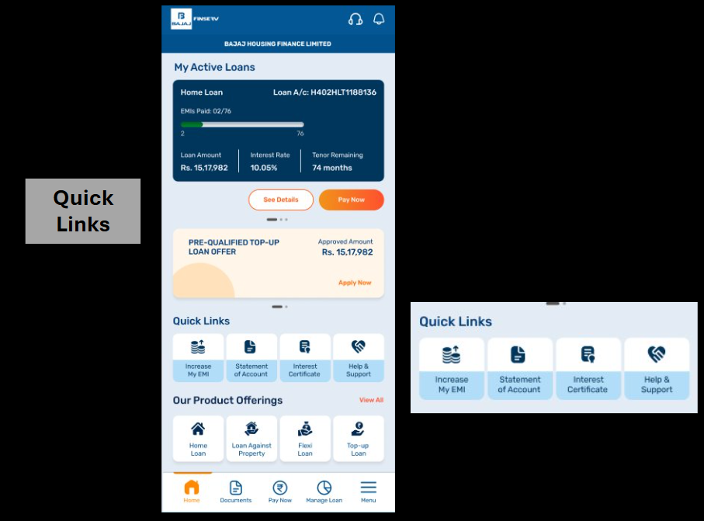

1. Tile Behavior: All tiles under **Quick Links** must be clickable (the element as a whole and not just the text)
2. Redirection Behavior: All tiles under **‘Quick Links’** should redirect directly to the specific landing screen/Overlay pop-up; These redirections should be customised to the Quick Links tiles:

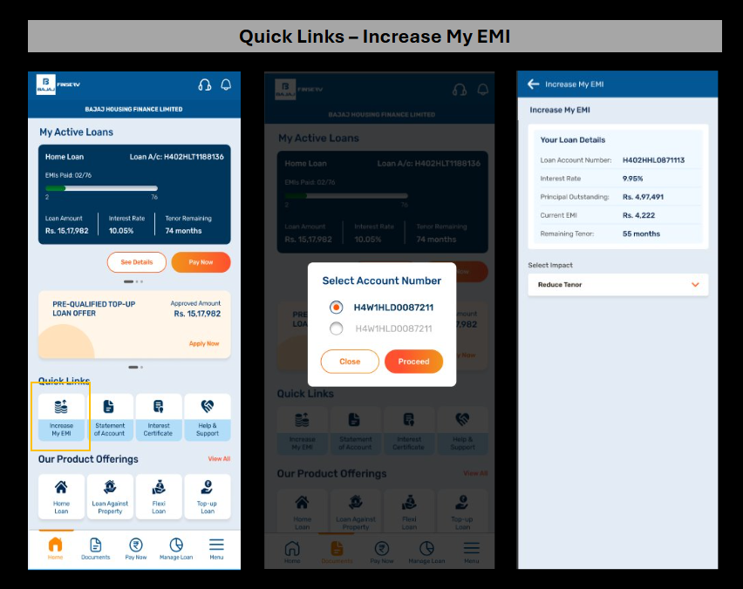

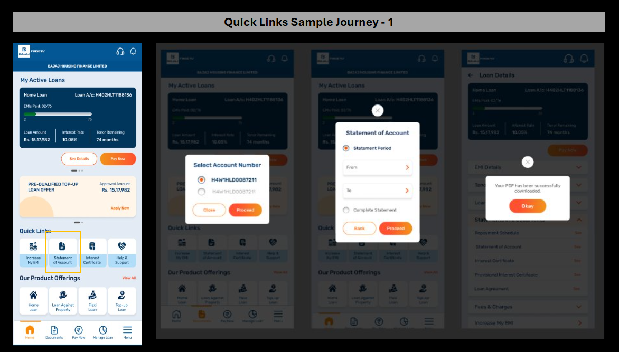

|  |  |
| --- | --- |
| Tile + Tile Name | Destination |
| Increase My EMI | When the user clicks on **‘Increase My EMI’**, they should be redirected to the **‘Increase My EMI’ landing screen,** with the LAN pre-populated in the **‘Your Loan Details’ card**;  However, if the user has more than one LAN, the **‘Select Account Number’ pop-up should appear**  – the user will make this selection on their own; following which the journey will be repeated |
| Statement of Account | When the user clicks on ‘Statement of Account’, the screen should change to **‘Loan Details’**, with the **‘Statements and Documents‘** component open.  On that, ‘Statement of Account’ pop-up should appear, where the user can make their preferred selection, and complete the action. Upon success, they should be shown the ‘success’ pop-up. Note that the screen should have a translucent overlay, as shown in the Figma  However, if the user has more than one LAN, the **‘Select Account Number’ pop-up** should appear first, on the existing screen. After the user makes a selection, the journey from above is repeated |
| Interest Certificate | When the user clicks on **‘Interest Certificate’**, the screen should change to **‘Loan Details’,** with the **‘Statements and Documents‘** component open.  On that, the **‘Interest Certificate’** pop-up should appear, where the user can make their preferred selection, and complete the action. Upon success, they should be shown the **‘success’** pop-up. Note that the screen should have a translucent overlay, as shown in the Figma  However, if the user has more than one LAN, the **‘Select Account Number’ pop-up** should appear first, on the existing screen. After the user makes a selection, the journey from above is repeated |
| Help & Support | When the user clicks on ‘Help & Support’, the ‘Help & Support’ screen should appear |

### 5.B. Home > Docked Footer

The existing App does have a footer, however, we will be revising the entire build from scratch. The new **‘Docked Footer’** is meant to provide all key journeys at their fingertips.

Please update the content, UI, and journey behavior as given in the Figma

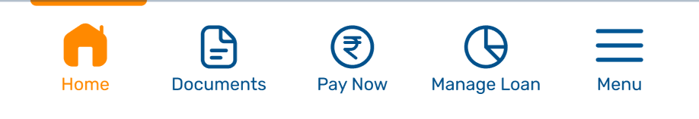

1. In total, there are **5 options** available in the docked footer
2. Open drawer state should have a build of up to **8 tiles**; note that we do not have to show all 8 tiles – the selection should be configurable; it only means that at any given time, open drawer can have up to **8 options**
3. Each tile has a ***tile title***, please update as per Figma
4. **Docked Footer Behavior:**

* Home: No change of screen or state if the user is already on the **‘Home’** screen; however, if the user is in a different screen, upon clicking, they should be brought back to the **‘Home’** screen:

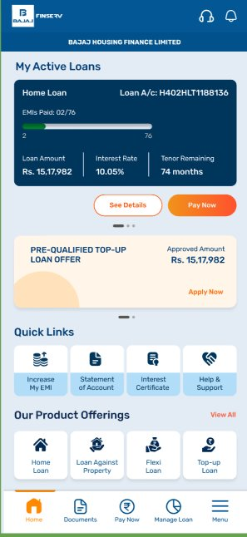

* Documents: When the user clicks on ‘Documents’, a bottom drawer should appear, showcasing all 5 tiles. Each subsequent journey has been mapped below:

***Note:*** Wherever the **‘Select Account Number’** pop-up is shown to the user, the primary LAN should be selected on the pop-up:

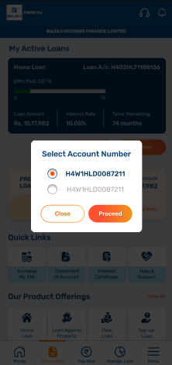

|  |  |  |  |
| --- | --- | --- | --- |
| Tile Name | Content Inclusions | Tile Behavior | Redirectional Behavior |
| Documents | Statement of Account | Upon selection, the tile should have an outline; as shown in the Figma | When the user clicks on ‘Statement of Account’, the screen should change to **‘Loan Details’**, with the **‘Statements and Documents‘** component open.  On that, ‘Statement of Account’ pop-up should appear, where the user can make their preferred selection, and complete the action. Upon success, they should be shown the ‘success’ pop-up. Note that the screen should have a translucent overlay, as shown in the Figma  However, if the user has more than one LAN, the **‘Select Account Number’ pop-up** should appear first, on the existing screen. After the user makes a selection, the journey from above is repeated |
| Repayment Schedule | Upon selection, the tile should have an outline; as shown in the Figma | When the user clicks on **‘Repayment Schedule’**, the screen should change to **‘Loan Details’**, with the **‘Statements and Documents‘** component open.  On that, the **‘Repayment Schedule’** pop-up should appear, where the user can make their preferred selection, and complete the action. Upon success, they should be shown the ‘success’ pop-up. Note that the screen should have a translucent overlay, as shown in the Figma  However, if the user has more than one LAN, the **‘Select Account Number’ pop-up** should appear first, on the existing screen. After the user makes a selection, the journey from above is repeated |
| Interest Certificate | Upon selection, the tile should have an outline; as shown in the Figma | When the user clicks on **‘Interest Certificate’**, the screen should change to **‘Loan Details’**, with the **‘Statements and Documents‘** component open.  On that, **‘Interest Certificate’** pop-up should appear, where the user can make their preferred selection, and complete the action. Upon success, they should be shown the ‘success’ pop-up. Note that the screen should have a translucent overlay, as shown in the Figma  However, if the user has more than one LAN, the **‘Select Account Number’ pop-up** should appear first, on the existing screen. After the user makes a selection, the journey from above is repeated |
| Provisional Interest Certificate | Upon selection, the tile should have an outline; as shown in the Figma | When the user clicks on **‘Provisional Interest Certificate’**, the screen should change to **‘Loan Details’**, with the **‘Statements and Documents‘** component open.  On that, **‘Provisional Interest Certificate’** pop-up should appear, where the user can make their preferred selection, and complete the action. Upon success, they should be shown the ‘success’ pop-up. Note that the screen should have a translucent overlay, as shown in the Figma  However, if the user has more than one LAN, the **‘Select Account Number’ pop-up** should appear first, on the existing screen. After the user makes a selection, the journey from above is repeated |
| Loan Agreement | Upon selection, the tile should have an outline; as shown in the Figma | When the user clicks on **‘Loan Agreement’**, the screen should change to **‘Loan Details’**, with the **‘Statements and Documents‘** component open.  On that, the ‘OTP’ tray must appear. Upon verification, they should be redirected to the ‘Loan Agreement’ screen (no screens beyond this) Note that the screen should have a translucent overlay, as shown in the Figma  However, if the user has more than one LAN, the **‘Select Account Number’ pop-up** should appear first, on the existing screen. After the user makes a selection, the journey from above is repeated |

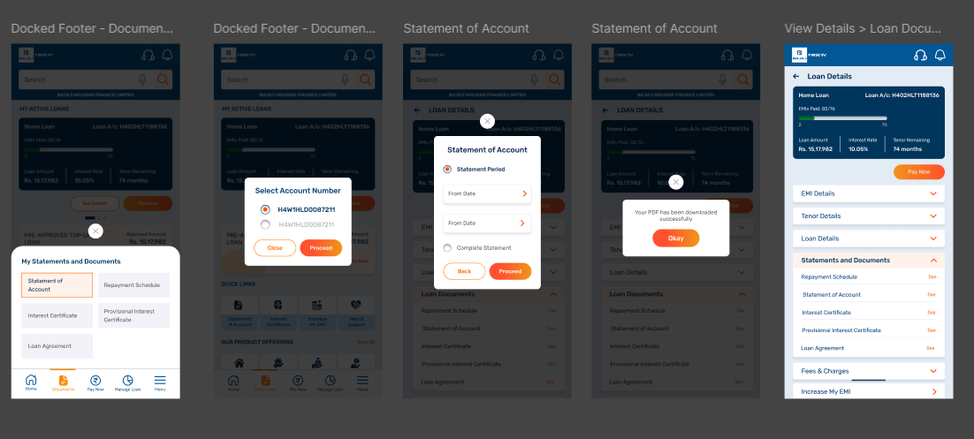

* Pay Now: Upon clicking **‘Pay Now’,** the default **Online Payments** landing page should appear. The **‘Select Account Number’** field should be prepopulated if the user has only **one LAN;** if the user has more than one LAN, the field should remain empty. Please recreate as per the journey shown in the Figma:

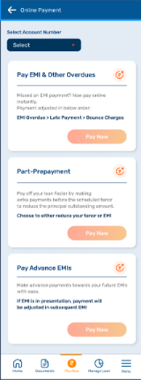

* Manage Loan: When the user clicks on ‘Manage Loan’, a bottom drawer should appear, showcasing all 2 tiles. Each subsequent journey has been mapped below:

|  |  |  |  |
| --- | --- | --- | --- |
| Component | Content Inclusions | Tile Behavior | Redirectional Behavior |
| Manage Loan | Increase My EMI | Upon selection, the screen should change | When the user clicks on **‘Increase My EMI’**, they should be redirected to the **‘Increase My EMI’ landing screen,** with the LAN pre-populated in the **‘Your Loan Details’ card**;  However, if the user has more than one LAN, the ‘Increase My EMI’ journey from Quick Links has to be recreated |
| Request for a Top-up Loan | Upon selection, the screen should change | Upon selection, the screen should change to the **‘My Offers**’ landing screen. Once there, the state should have the **‘Top-up Loan’** tile highlighted under the **‘Request a Custom Offer’** section |

* Menu: Upon clicking **‘Menu’,** the default **‘Menu Screen’** should appear. Please recreate as per the journey shown in the Figma:

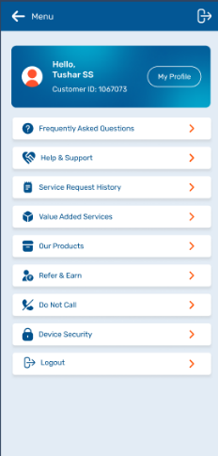

# Loan Details

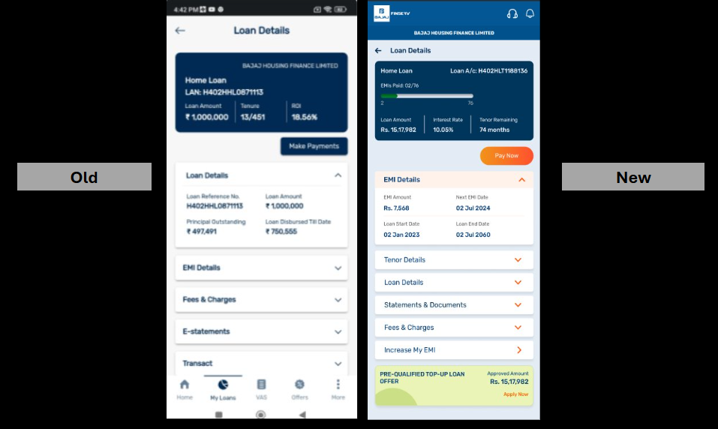

The overall structure and functionality of this screen remains the same; a one-stop-shop for all loan-related details for the **selected LAN.** There are some removals and some new inclusions; please follow all content and UI directions, and journeys as provided in the Figma:

1. The existing **‘Loan Details’** top-strip is replaced by a header
2. Under the header, the screen title has been added: ‘Loan Details’
3. The ‘back arrow’ should take the user back to the ‘Home’ screen
4. The **blue loan card** only has content level changes, and UI alignment changes; please update as per the Figma
5. The ‘**EMI Paid’ slider** should be replicated from what is already present on the ‘Home’ screen; **no change in logic w.r.t. to the data being fetched**
6. All existing CTAs should be retained; however, CTAs should be given the revised treatment, as shown in the Figma
7. The **‘Loan Details’** default state should always have the **‘EMI Details’** component open
8. The order of the dropdown components has been changed:

|  |  |
| --- | --- |
| Existing Order of Dropdown Components | New Order of Dropdown Components |
| Loan Details | EMI Details |
| EMI Details | Tenor Details |
| Fees & Charges | Loan Details |
| E-Statements | Statements & Documents |
| Transact | Fees & Charges |
| Loan Documents | Increase My EMI |

***Please note:***

* The Dropdown components highlighted in red should be dropped
* The Dropdown components highlighted in yellow should be now added to the ‘Loan Details’ page

1. ***Dropdown component* behavior:** All dropdown components should retain their existing behavior, i.e., **upon clicking anywhere on the closed states of the component, the same should be open with all details**
2. In their open states, the **‘downward orange arrow’** should be updated to the **‘upward orange arrow’** indicating that the user has click on it to close the card; the **only exception is ‘Increase My EMI’**

### 6.A. Loan Details > EMI Details

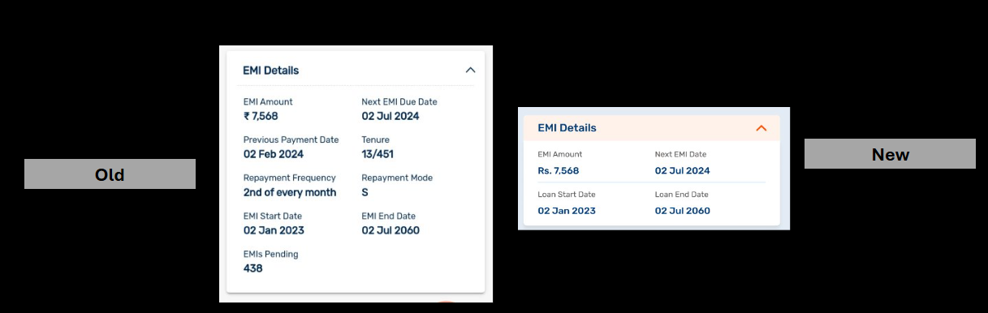

a) The **’EMI Details’** component has only some content changes; wherein, parameters such as **’Previous Payment Date’, ’Tenure’, ’Repayment Frequency’, ’Repayment Mode’,** and **’EMIs Pending’** have been removed

b) Other content hygiene changes have been made; to be incorporated as provided in the Figma file

c) *Component behavior:* No change in the behavior of this component, from what is existing

### 6.B. Loan Details > Tenor Details

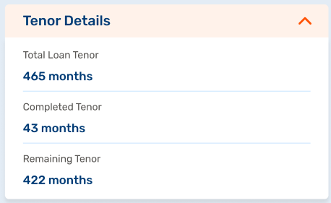

a) The ’**Tenor Details’** is a new addition in the dropdown components, however, the information showcased here is essentially taken from the existing ‘EMI Details’ component and the main Loan Card at the top of the ‘Loan Details’ page; there should ideally be no change in how this data is fetched

b) Other content hygiene changes have been made; to be incorporated as provided in the Figma file

c) *Component behavior:* No change in the behavior of this component, from what is existing

### 6.C. Loan Details > Loan Details

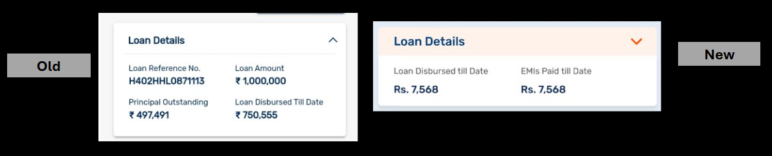a) The **’Loan Details’** component has only some content changes; wherein, parameters such as **’Product Name’, ’Principal Outstanding’,** and **‘Tenure’** have been removed.

Note that **‘Dropline Limit’** should appear for those users whose loans are mapped. ***There should ideally be no change in how this data is fetched***

b) Other content hygiene changes have been made; to be incorporated as provided in the Figma file

c) *Component behavior:* No change in the behavior of this component, from what is existing

### 6.D. Loan Details > Statements & Documents

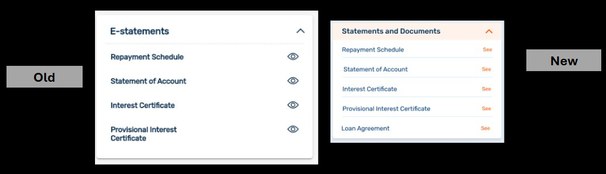

a) The **’Statements & Documents’** component’s overall behavior remains the same, wherein, if the user clicks on the ‘eye’ icon, each subsequent journey is completed through pop-ups

b) Component title has been updated to **‘Statements & Documents’**

c) In addition to the four existing documents, an additional document has been added to the component tray: **Loan Agreement**

d) Since each journey is originating from a **LAN specific screen,** the **‘Select Loan Account’** pop-up will not be needed anywhere

e) Each journey has been mapped out in the Figma; please update as is:

* Statement of Account: (SNIPS NEED UPDATING)

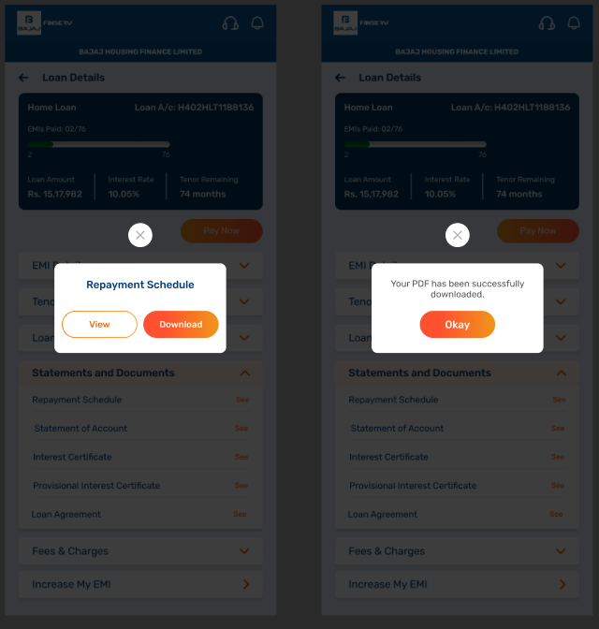

* Repayment Schedule

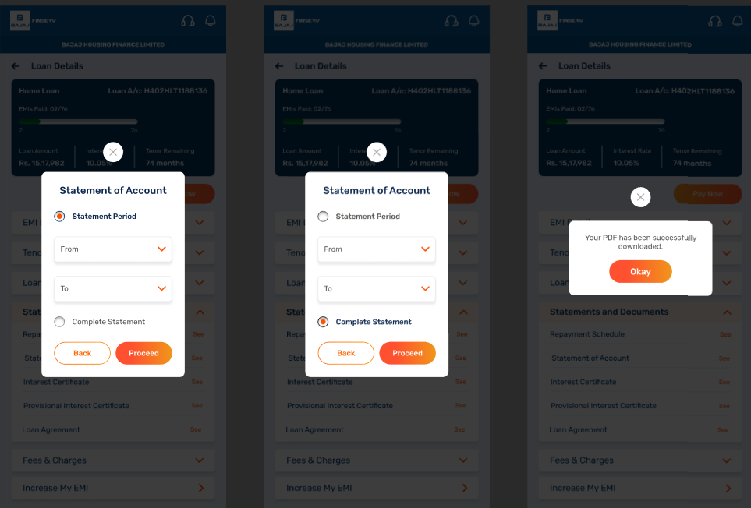

* Interest Certificate

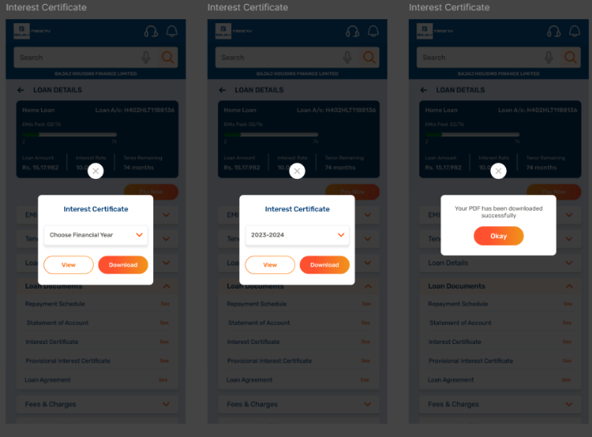

* Provisional Interest Certificate

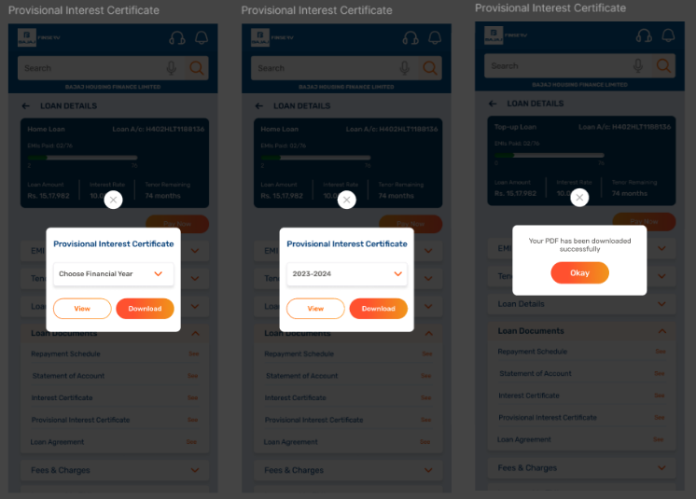

* Loan Agreement

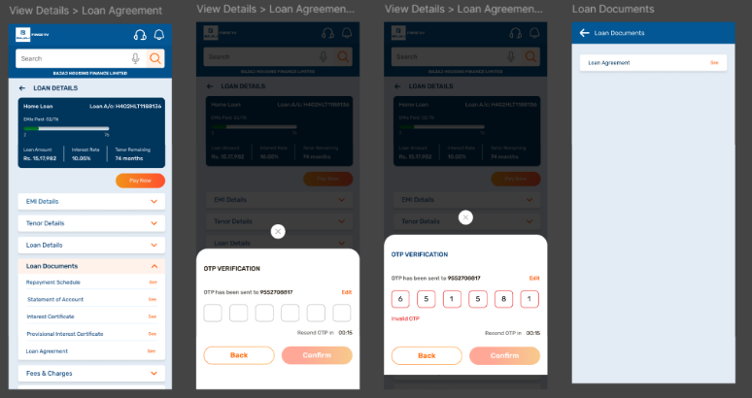

6.E. Loan Details > Fees & Charges

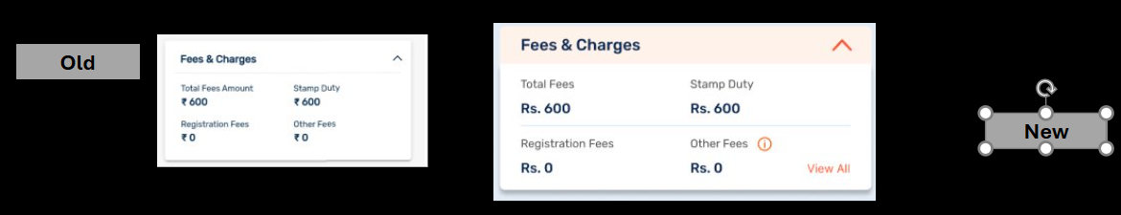a) The **’Fees & Charges’** component has some content hygiene changes; please update as per the Figma

b) *New Element:* A new **‘View All’** text has been added to the RHS lower corner of the component; when the user clicks on the same, they should be redirected to the ‘Fees & Charges’ Details screen:

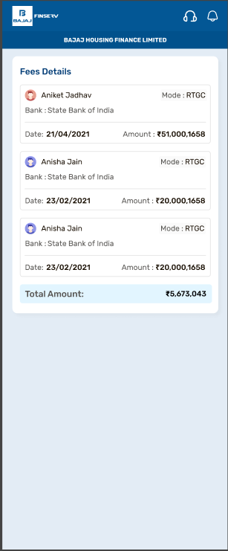

**Note:** Essentially, this screen is a recreation of the Customer Portal’s ‘Fees Details’ card; hence, the logic to fetch the data should be replicated here as well.

c) *Component behavior:* No change in the behavior of this component, from what is existing

### 6.F. Loan Details > Increase My EMI

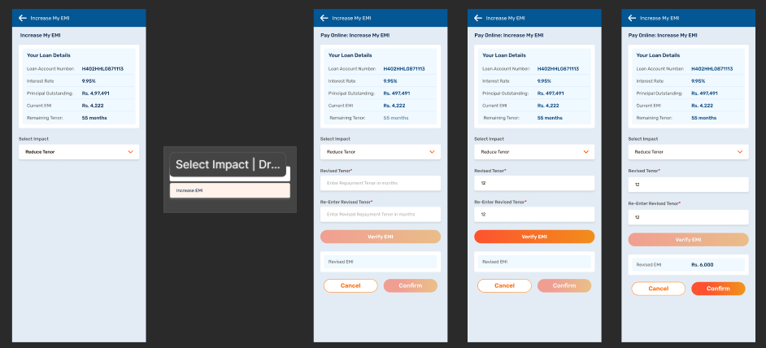

a) The **’Increase My EMI’** component is a new addition in the dropdown components; however, the journey for the same does already exist on the app (***current path: More > Self Service > Change Number of Instalments/EMI)*** , so the new journey included in the Figma is an optimised version of the same

b) Content Change: Name of the journey has been updated to **‘Change Number of Instalments/EMI’** to **‘Increase My EMI’**

c) *Component behavior:* When a user clicks on the arrow in the component, they should be redirected to the **‘Increase My EMI’** default state. Note that the **LAN is prepopulated in the ‘Your Loan Details’** Card:

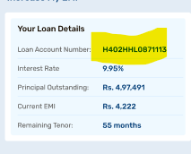

d) ‘Increase My EMI’ screen description:

* Tool tip added to the Page Title: *Adjust your repayment and repay your loan quicker, by increasing your EMI or reducing your repayment tenor.*
* Details showcased in the **‘Your Loan Details**’ card: there is no change in the list of details shared here, hence no change in the logic of fetching this data set, only content hygiene should be adhered to, as per the Figma
* All mandatory fields have a red asterisk next to the Field Name; the **‘Verify EMI**’ or the **‘Verify Tenor’** CTA should not be enabled till all required fields don’t have inputs:

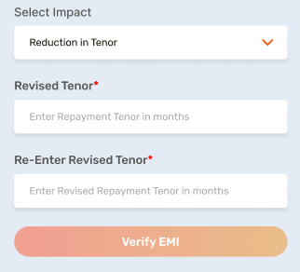 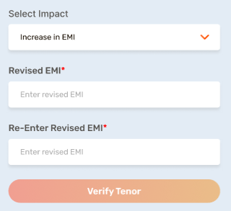

* The fields in this screen also have in-field text; please update as shown in the Figma:

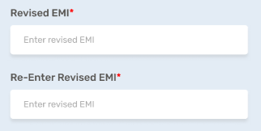

e) ‘Increase My EMI’ journey description:

All changes suggested here are just enhancements and content/UI changes; there is no change in the logic of this journey, hence there should be no change in the data fetched either:

* Once the user selects in the **‘Select Impact’** field, the subsequent fields should appear. The two options for the user are the same as existing: **‘Reduce Tenor’** or **‘Increase EMI’:**

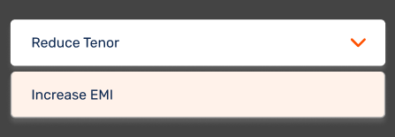

* There subsequent fields and behavior are identical to the existing journey, hence there should be no change in the logic of how the data is fetched:

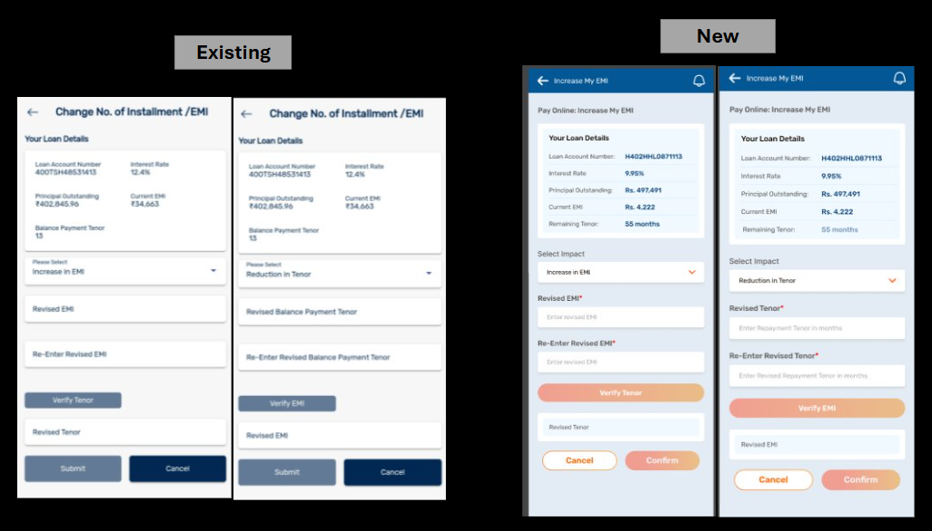

* Once the user is shown the value in the **’Revised Tenor**' and **‘Revised EMI’** field, the **‘Verify Tenor’** and the **‘Verify EMI’** CTAs should no longer be enabled.
* The **‘Confirm’** CTA should only be enabled only after the **‘Revised Tenor' and ‘Revised EMI’ fields have values and have been validated correctly**
* If the user clicks on **‘Confirm’,** an OTP submission pop-up should appear; please update the journey as per the Figma

f) ‘Increase My EMI’ Field Validations:

We have provided the sample screens for error states on this journey in the Figma; the same should be updated as per the error-scenarios mapped below:

|  |  |  |  |  |  |  |
| --- | --- | --- | --- | --- | --- | --- |
| **Field Name** | **Description** | **Field Type** | **Dropdown options** | **Length** | **Validation** | **Error Message** |
| Select Impact | To determine if user wants to increase EMI or reduce loan tenor | Dropdown | Reduction in Tenor |  | User doesn’t select dropdown option | Please choose between the two available options. |
| Increase in EMI | User doesn’t select dropdown option | Please choose between the two available options. |
| Revised Tenor | User to input the reduced loan tenor | Text input – should only have numericals here | N/A | Cannot exceed 3 characters | User leaves the field blank | Please fill in all the required fields to proceed. |
| User’s loan tenor is higher than existing loan tenor | The revised tenor should be lower than the existing tenor. |
| User’s loan tenor is lower than 24 months | The revised tenor should be higher than 24 months. |
| Revised EMI | User to input the reduced loan tenor | Text input – should only have numericals here | N/A | Cannot exceed 9 character: X,XX,XXX | User leaves the field blank | Please fill in all the required fields to proceed. |
| User’s revised EMI is lower than existing EMI | The revised EMI should be higher than the existing EMI. |
| Re-Enter Revised Tenor | User to input revised tenor | Text input – should the same as in the ‘Revised Tenor’ field | N/A | N/A | User leaves the field blank | Please fill in all the required fields to proceed. |
| Values do not match with the value in the ‘Revised Tenor’ field | The values entered do not match. |
| Re-Enter Increased EMI | User to input revised EMI | Text input – should the same as in the ‘Revised EMI’ field | N/A | N/A | User leaves the field blank | Please fill in all the required fields to proceed. |
|  |  |  |  |  | Values do not match with the value in the ‘Revised EMI’ field | The values entered do not match. |

### 6.G. Loan Details > Top-up Loan Entry Way

This is a new addition to the screen, mainly to allow the user an easy access/entry point to apply for a top-up loan on the Loan Details screen as well.

1. When the user clicks anywhere on the banner, it should open on the ‘My Offers’ screen, with the ‘Top-up Loan’ tile highlighted, under the ‘Request a Customer Offer’ component. Please update as per Figma

Note that as the user already has an offer, the same offer amount should be prepopulated in the ‘Loan Amount Field’

1. The user should also be able to ‘edit’ the Top-up Loan Amount, basis their requirements. Please note that no additional validations for this field have been provided; Dheeraj to share all validations mapped against this journey, including min and max values for us to reshare this.

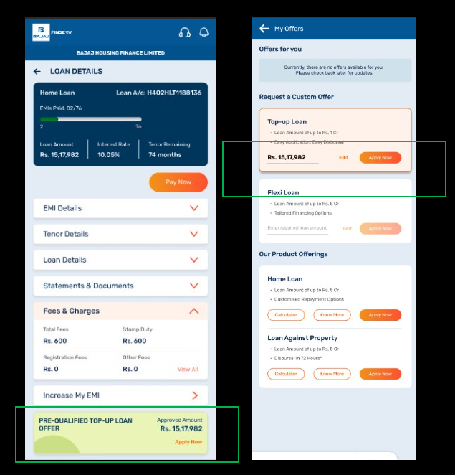

* Component Behavior: If the user clicks on **‘edit**’ in the field, then the mobile keyboard (number-pad state only) should appear in the user’s mobile device

# Online Payment

The **‘Pay Now’** CTA leads to the **Online Payment screen**, which is a new screen built. Essentially, this is the same as the **Online Payments page on the Customer Portal.**

There are three paths that lead to the Online Payment screen:

* Through the **Docked Footer** – pathway defined in the **‘Home > Docked Footer’** section of the BRD
* Through the ‘**Pay Now’ CTA on the ‘Home Screen’** - pathway defined in the ‘Home’ section of the BRD
* Through the **‘Pay Now’ CTA on the ‘Loan Details’** screen – pathway defined below:

### 7.A. Online Payment > Loan Details Screen > ‘Pay Now’

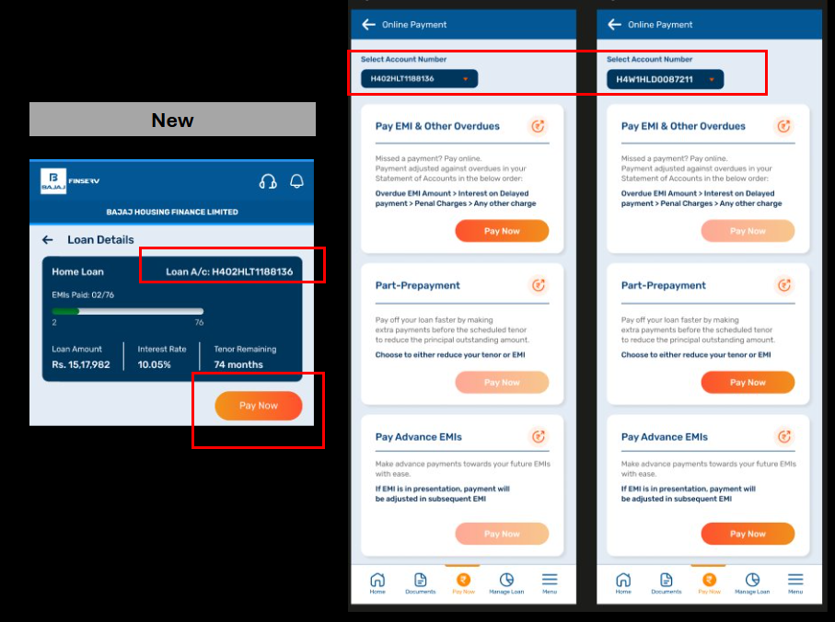a) When the user selects **‘Pay Now’** from under the blue loan card on the ‘Loan Details’ page, they should be redirected to the **Online Payment screen**

b) The **‘Select Account Number’** dropdown should be prepopulated, as the pathway originated from a LAN specific card

c) Dynamic behavior:

* The **‘Pay Now’ CTA** on the **‘Pay EMI & Other Overdues’** card needs to be disabled if the user has ***zero overdue EMIs and other dues***
* The **‘Pay Now’ CTAs** on the ‘**Part-Prepayment’ and ‘Pay Advance EMI’** cards need to be disabled if the users have greater than ***zero overdue EMIs, or has other pending dues***

**Note** that there will be no change in the logic of fetching this data from the backend

### 7.B. Online Payment > Pay EMI & Other Overdues

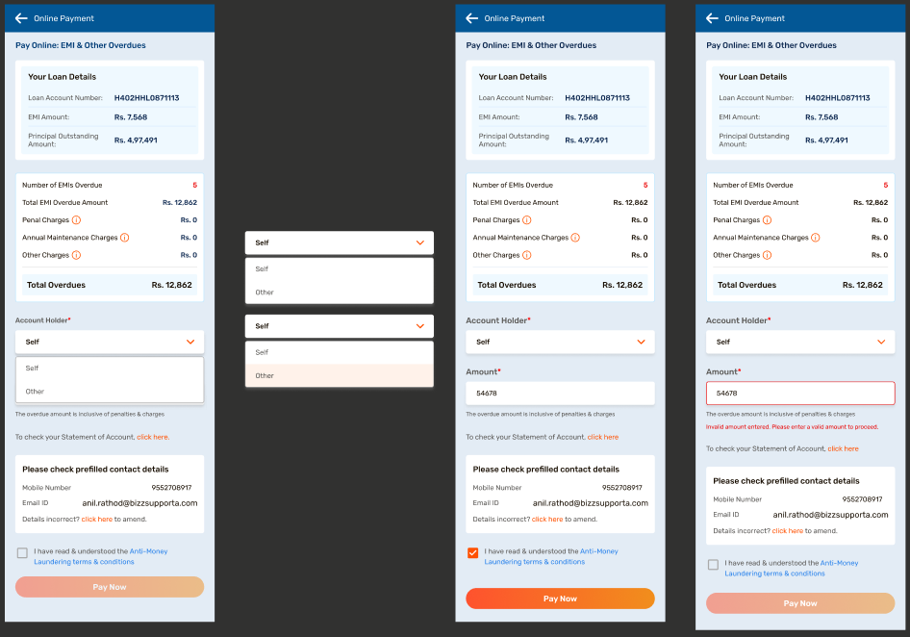a) When the user selects **‘Pay Now’ CTA** on the **‘Pay EMI and Other Overdues’** card, they should be redirected to the **‘Pay EMI and Other Overdues’** default screen

b) The ‘back arrow’ on the header should redirect the user to the ‘Online Payment’ default state – as per the user’s LAN selection

***C) ‘Number of EMIs Overdue’*** has also been added to the loan card details; we have showcased only EMI overdue amount here; we also need to showcase the Number of EMIs Overdue. Please add the same as a field before EMI overdue (as indicated in the Figma)



D) Info tips have also been added, which will appear as a pop-up overlay if the user hovers/clicks on the **‘i’ button:** 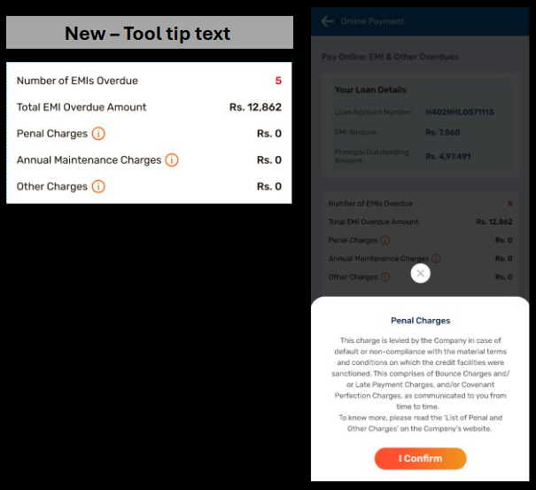

Please update the text for each tool-tip pop-up, basis the Figma screen provided:

* **Penal Charges:** This charge is levied by the Company in case of default or non-compliance with the material terms and conditions on which the credit facilities were sanctioned. This comprises of Bounce Charges and/or Late Payment Charges, and/or Covenant Perfection Charges, as communicated to you from time to time.

To know more, please read the ‘List of Penal and Other Charges’ on the Company’s website.

* **Annual Maintenance Charges: awaiting clarity**
* **Other Charges: Awaiting clarity**

E) Default behavior: Whenever the user lands on this screen, **‘Self’** should be selected as the default option in the **‘Account Holder’\*** field.

F) The **‘To check your Statement of Account, click here’** has also now been added, as per the existing build on the Customer Portal above **‘Please check prefilled contact details’:**

This document should be fetched from the back-end; ***Dheeraj to advice on how to navigate the mapping***

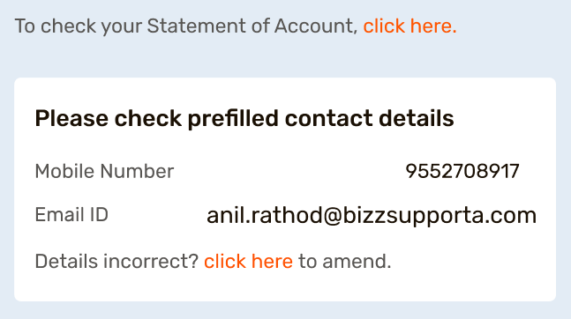

G) *Elements to remove:*

* The sentence ‘**Click here for payment guidelines & disclaimer’** should be removed



H) *Dynamic Behavior:* The fields **‘Name of Account Holder’** and **‘Relationship with Account Holder’** should be hidden by default. ONLY IF the user selects ‘Other’ under **‘Account Holder’**, then the two fields should appear. Please refer to the screenshot attached, and Figma

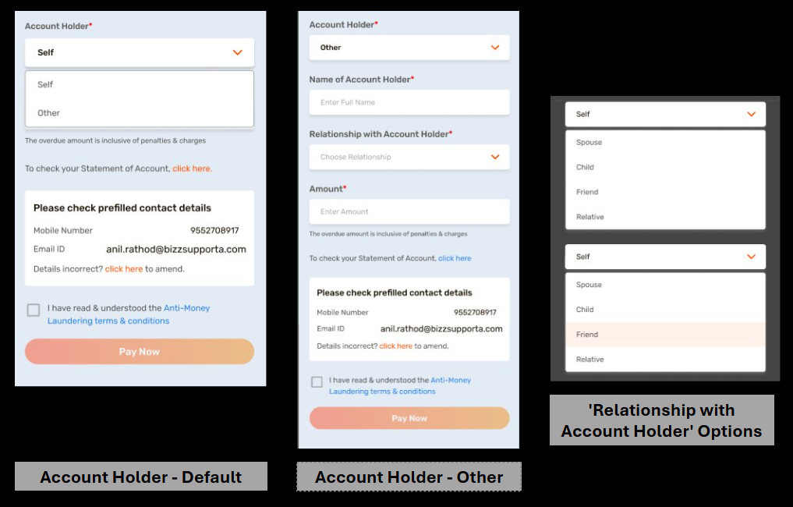

I) *Optimising & Standarding Existing Elements:*

* The header’s appearance has been changed; however, the back arrow functionality should be kept the same as the existing UI. This should be standardised as per the Figma, wherever it may appear:

Old:

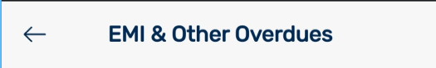

New:



* The **‘Please check prefilled contact details’** component needs to be standardized across screens. The component should only have two information fields showcased – **Contact Number** and **Email ID**.

Plus, in case the user finds the number to be incorrect, they should be able to go to a page where these can be amended. Please change all aspects as per Figma.

Old:

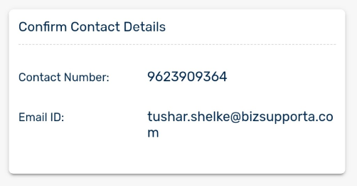

New:

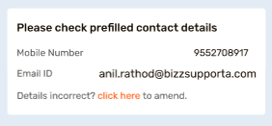

* The T&C component should be just above the New CTA placement (refer to Figma) and not where it currently is. Please rearrange as per Figma; ***no other change from existing behavior***

Old:

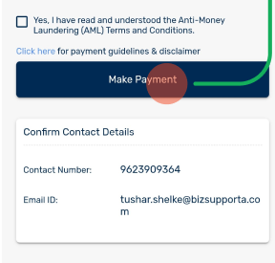

New:

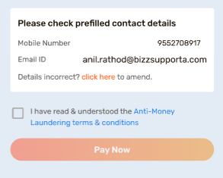

J) Content changes have been on the Figma; please make the changes as given wherever applicable

K) The AML ‘pop-up’ also has to be standardised as per the UI provided in the Figma:

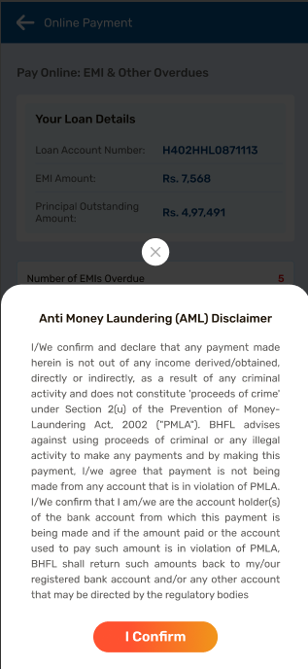

K) All fields have in-field texts; please standardise as per the UI and content provided in the Figma

L) CTA behavior: The ‘Pay Now’ CTA should not be enabled till all mandatory fields have been filled, and the T&C box has been checked

M) Error scenarios: As the error states are already given as a template in the Figma, the following error scenarios should be mapped:

|  |  |  |  |
| --- | --- | --- | --- |
| **Field Name** | **Event** | **Trigger** | **Error Message** |
| All | Mandatory fields left empty | ‘Pay Now’ CTA selected | Please fill in all the required fields to proceed. |
| Name of Account Holder | If full name, as per, the registered records | ‘Pay Now’ CTA selected | Please enter the full name. |
| Name of Account Holder | If special characters have been inserted | ‘Pay Now’ CTA selected | Full name cannot contain special characters. Please try again. |
| Amount | Amount entered is incorrect; **Dheeraj to give all scenarios** | ‘Pay Now’ CTA selected | Invalid amount entered. Please enter a valid amount to proceed. |
| AML terms and conditions | User has not marked the check-box | ‘Pay Now’ CTA selected | Please agree to the terms & and conditions to continue. |

### 7.C. Online Payment > Part-Prepayment

Again, from a ‘journey’ point of view, there is no change from the existing builds on the App and the Customer Portal. Largely, all changes are UI/Content and design level; please update exactly as per the Figma: 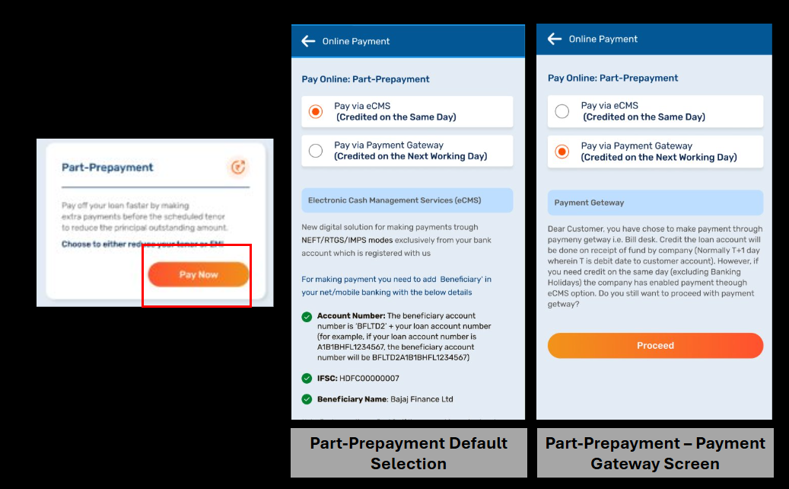

### **STATES:**

#### 7.C.1. Part-Prepayment > Pay via eCMS

**Major UI changes** are needed since information hierarchy needs to be defined and clear callouts are needed to draw user attention to important points. Please refer to the Figma for the exact changes.

There will also be **multiple content changes;** please adhere to changes shown in the Figma:

a) When the user selects **‘Pay Now’** on the **‘Part-Prepayment’** card, they should be redirected to the ‘Part-Prepayment’ default screen – here, the radio button must be selected for **‘Pay via eCMS**’

b) Telection does not further redirect the user to a different location; the current state is the default state for **‘Pay via eCMS**’

c) *Functionality Change and elements to remove:* At present, the screen shows a bunch of text to the customer and then there is a **‘Know More’** CTA., which again takes the user to another page, which only has content with no CTA as such. This confusing for the user since the navigation to another page makes one feel like the system will allow some action there.

Thus, this page needs to be redone as per the Figma, wherein there is no further navigation for the user.

Old:

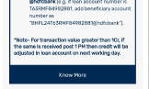

New:

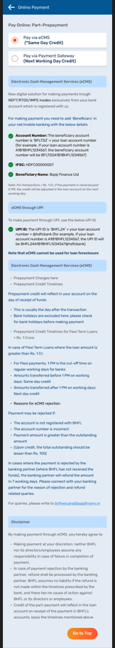

d) *New element addition:* At the bottom of the default page, we need to add a new CTA button, **‘Go to Top’** to ease the user’s experience and reduce scroll time:

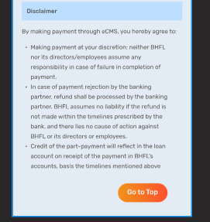

#### **7.C.2. Part-Prepayment > Pay via Payment Gateway**

The content has been changed substantially to maintain hygiene and accuracy. Please refer to the Figma and update accordingly.

a) In the default state, if the user selects ‘**Pay via Payment Gateway’,** the default content (eCMS text) should get replaced with the following; please update as per the Figma:

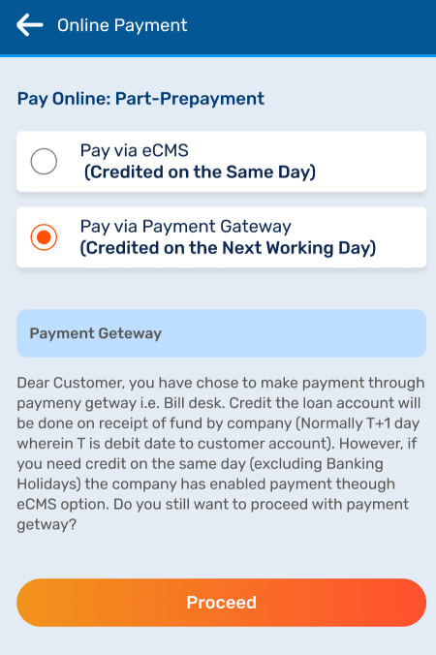

b) Once the user selects the **‘Proceed’** CTA, they should then be taken to the next screen; please follow the journey as shown in the Figma

C)Parameters in the ‘Your Loan Details’ card now include **‘Total Loan Amount’** and **‘Remaining Tenor’;** this data again should be fetched from the backend to reflect on these cards, basis the LAN mapped

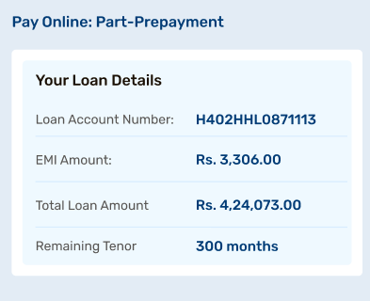

D) Parameters such as **‘Principal Outstanding’, ‘Utilized Amount’ and ‘Total Tenure’** have been removed from the **‘Your Loan Details’** card:

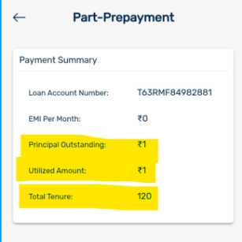

*E) Dynamic Behavior:* The fields **‘Name of Account Holder’** and **‘Relationship with Account Holder’** should be hidden by default. ONLY IF the user selects ‘Other’ under **‘Account Holder’**, then the two fields should appear – please update as per the journey on Figma. Note that the default state for the **‘Account Holder’** field should be **‘Self’**

F) CTA behavior: The **‘Pay Now’** CTA should not be enabled till all mandatory fields have been filled, and the T&C box has been checked

G) A **‘Note’** text has been added under the **‘Please check your prefilled contact details’** component:

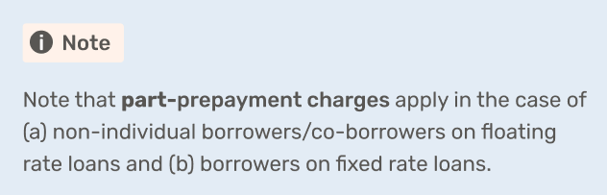

H) A **‘Click here for Part-Prepayment guidelines’** has been added under the last form field **‘Amount’;** when the user clicks on the hyperlink, the content should open in the standardised pop-up format, as shared in the Figma - Manasi needs to create this screen

I) At present, the page also included a note, titled **‘Fixed Rate Loans: All Borrowers’,** which we need to remove:

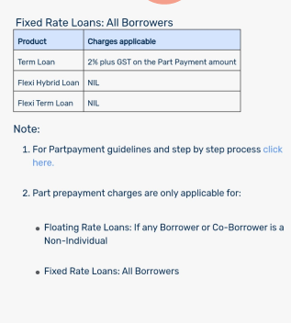

*J) Optimising & Standardising Existing Elements:*

* The header’s appearance has been changed; however, the back arrow functionality should be kept the same as the existing UI. This should be standardised as per the Figma, wherever it may appear
* The **‘Please check prefilled contact details’** component needs to be standardized across screens. The component should only have two information fields showcased **– Mobile Number** and **Email ID**.

Plus, in case the user finds the number to be incorrect, they should be able to go to a page where these can be amended. Please change all aspects as per Figma

* The T&C component should be just above the CTA (as per new CTA placement) and not where it currently is. Please rearrange as per Figma; ***no other change from existing behavior***
* All fields have in-field texts; please standardise as per the UI and content provided in the Figma
* The AML ‘pop-up’ also has to be standardised as per the UI provided in the Figma

1. Error scenarios: As the error states are already given as a template in the Figma, the following error scenarios should be mapped:

|  |  |  |  |
| --- | --- | --- | --- |
| **Field Name** | **Event** | **Trigger** | **Error Message** |
| All | Mandatory fields left empty | ‘Pay Now’ CTA selected | Please fill in all the required fields to proceed. |
| Name of Account Holder | If full name, as per, the registered records | ‘Pay Now’ CTA selected | Please enter the full name. |
| Name of Account Holder | If special characters have been inserted | ‘Pay Now’ CTA selected | Full name cannot contain special characters. Please try again. |
| Amount | Amount entered is incorrect; **Dheeraj to give all scenarios** | ‘Pay Now’ CTA selected | Invalid amount entered. Please enter a valid amount to proceed. |
| AML terms and conditions | User has not marked the check-box | ‘Pay Now’ CTA selected | Please agree to the terms & and conditions to continue. |

### 7.D. Online Payment > Pay Advance EMIs

a) When the user selects the **‘Pay Now’** CTA on the ‘**Pay Advance EMIs’** card, they should be redirected to the **‘Pay Advance EMIs’** screen

B) no change in any of the parameters showcased in the ‘Your Loan Details' card; only content hygiene changes to be done as per the Figma

C) *Dynamic Behavior:* The fields **‘Name of Account Holder’** and **‘Relationship with Account Holder’** should be hidden by default. ONLY IF the user selects ‘Other’ under **‘Account Holder’**, then the two fields should appear – please update as per the journey on Figma

D) CTA behavior: The **‘Pay Now’** CTA should not be enabled till all mandatory fields have been filled, and the T&C box has been checked

E) *Optimising & Standardising Existing Elements:*

* The header’s appearance has been changed; however, the back arrow functionality should be kept the same as the existing UI. This should be standardised as per the Figma, wherever it may appear
* The **‘Please check prefilled contact details’** component needs to be standardized across screens. The component should only have two information fields showcased – **Contact Number** and **Email ID**. Plus, in case the user finds the number to be incorrect, they should be able to go to a page where these can be amended. Please change all aspects as per Figma
* The T&C component should be just above the CTA and not where it currently is. Please rearrange as per Figma; ***no other change from existing behavior***
* All fields have in-field texts; please standardise as per the UI and content provided in the Figma
* The AML ‘pop-up’ also has to be standardised as per the UI provided in the Figma

1. The **note** section of the screen has been optimised from a UI and Content perspective, please update accordingly:

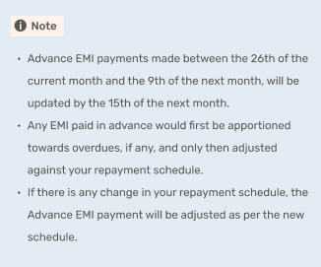

1. *Elements to remove:*  The sentence ‘**Click here for payment guidelines & disclaimer’** should be removed



1. Error scenarios: As the error states are already given as a template in the Figma, the following error scenarios should be mapped:

|  |  |  |  |
| --- | --- | --- | --- |
| **Field Name** | **Event** | **Trigger** | **Error Message** |
| All | Mandatory fields left empty | ‘Pay Now’ CTA selected | Please fill in all the required fields to proceed. |
| Name of Account Holder | If full name, as per, the registered records | ‘Pay Now’ CTA selected | Please enter the full name. |
| Name of Account Holder | If special characters have been inserted | ‘Pay Now’ CTA selected | Full name cannot contain special characters. Please try again. |
| Amount | Amount entered is incorrect; **Dheeraj to give all scenarios** | ‘Pay Now’ CTA selected | Invalid amount entered. Please enter a valid amount to proceed. |
| AML terms and conditions | User has not marked the check-box | ‘Pay Now’ CTA selected | Please agree to the terms & and conditions to continue. |

# Menu

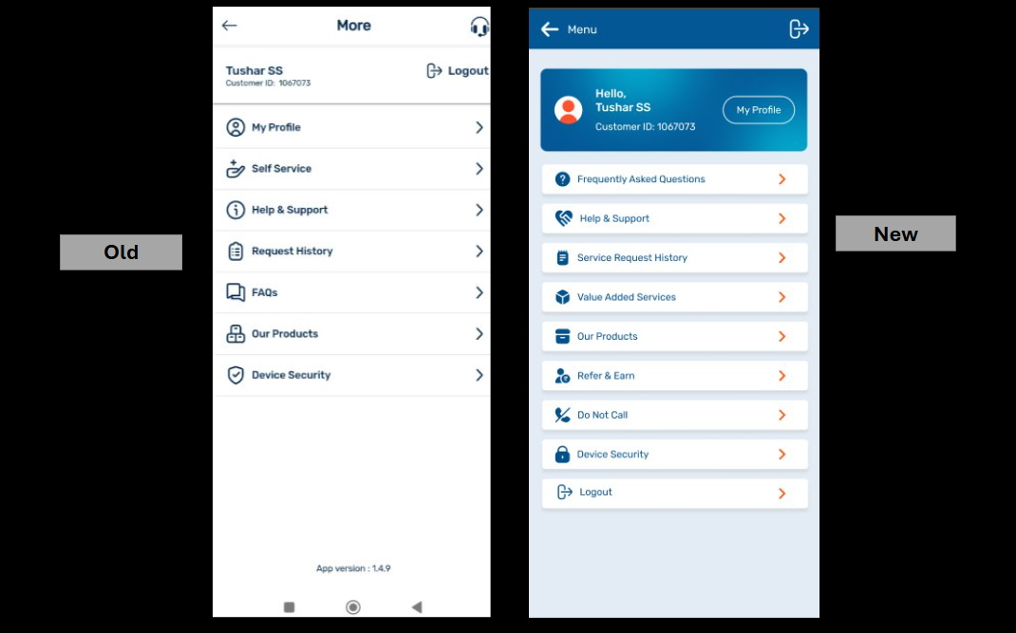

1. Pathway: The **‘Menu’ screen** should appear on the screen, when the user selects **‘Menu’** on the docked footer
2. UI level changes: Please update as per the Figma:

* The **‘My Profile’** card has been updated; there is now a ‘profile picture’ element added to the component, along with other UI level changes

Old:



New:

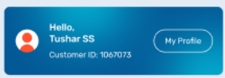

* At present, the first **‘Menu’** option is **‘My Profile’;** We need to move the entire component and its functionality into the **‘My Profile’** card . *Again, please note that only the position of the component is being moved; no change in the logic whatsoever*:

Old:

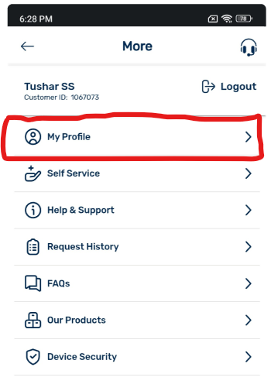

New:

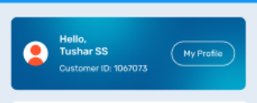

* The order of the dropdown menu options/components has been changed:

|  |  |  |
| --- | --- | --- |
| Existing Order of Dropdown Components | New Order of Dropdown Components | Redirection/Pathway |
| My Profile | Frequently Asked Questions | Same the existing build |
| Self-Service | Help & Support | New States & journey as shown in the Figma |
| Help & Support | Service Request History | Same as the existing build |
| Request History | Value Added Services | Same as existing build |
| FAQs | Our Products | Same existing build |
| Our Products | Refer & Earn | **T**o redirect to the **‘Customer Portal ‘Refer a Friend’** |
| Device Security | Device Security | Same as the existing build |
|  | Do Not Call | Should redirect to: <https://www.bajajhousingfinance.in/dnc-service> |
|  | Logout | Same as the existing build |

C) Dropdown component behavior: All dropdown components should have its existing behavior, i.e., upon selection, the user should be redirected to a new screen, basis the redirection pathways

D) Content changes: Please update the content basis the Figma provided

### 8.A. Menu > Help & Support

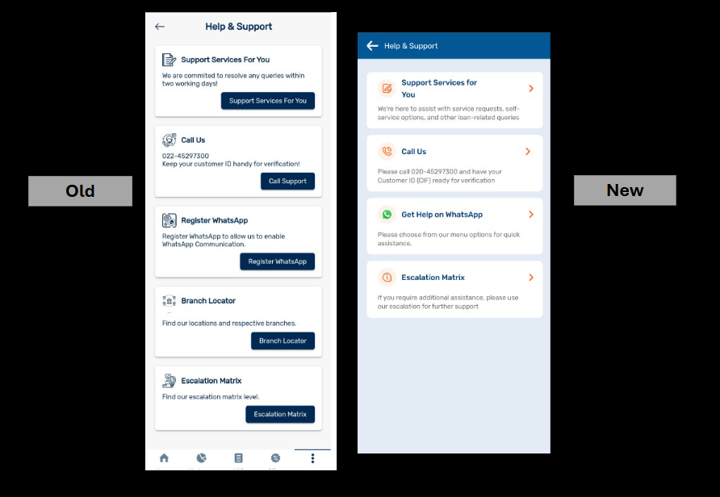

1. The order of the dropdown menu options/ components has been changed:

|  |  |  |
| --- | --- | --- |
| Existing Order of Dropdown Components | New Order of Dropdown Components | Redirection/Pathway |
| Support Services for You | Support Services for You | New States & journeys as shown in the Figma |
| Call Us | Call Us | Same as existing build; the entire journey is via pop-ups; **no change in logic, only UI standardisations,** wherever applicable as per the Figma |
| Register WhatsApp | Get Help on WhatsApp | Same as existing build; the entire journey is via pop-ups; no change in logic, only UI standardisations, wherever applicable as per the Figma  Note: The pop-up should eventually redirect to the Service WhatsApp Channel ***– We have not received screens beyond this*** |
| Branch Locator | Escalation Matrix | Same as existing build; no change in logic, only UI standardisations, wherever applicable as per the Figma |
| Escalation Matrix |  |  |

B) UI level changes: Please update as per the Figma

Icons have been updated; please amend as per Figma

C) Docked Footer: At present, the docked footer menu appears when the ‘Menu’ options are open. In the updated Figma, we should remove the docked footer from all subsequent states once the menu options open:

Old:

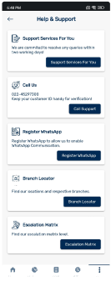

New:

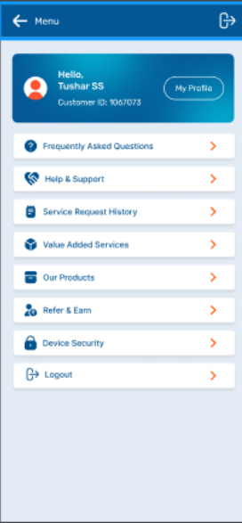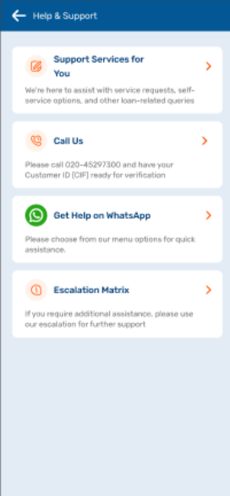

### 8.B. Menu > Help & Support > Support Services for You

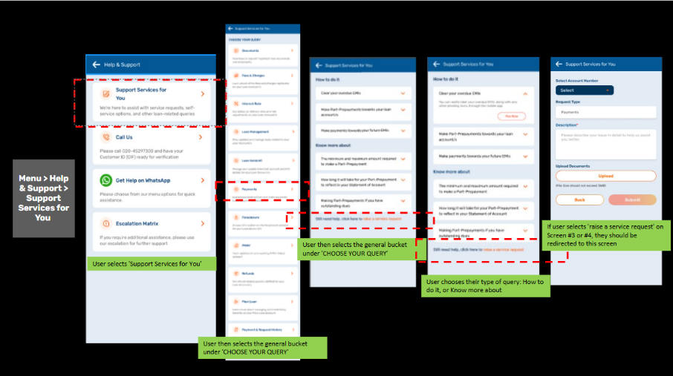  
  
a) When the user selects ‘Support Services for You’ from the menu options, they should be redirected to the ‘Choose Your Query’ screen, where they can choose the ’tile’/ ‘bucket’ under which their query falls

b) Component behavior: Each component should be clickable, wherein, the user is redirected to the subsequent states mapped against each **query bucket**

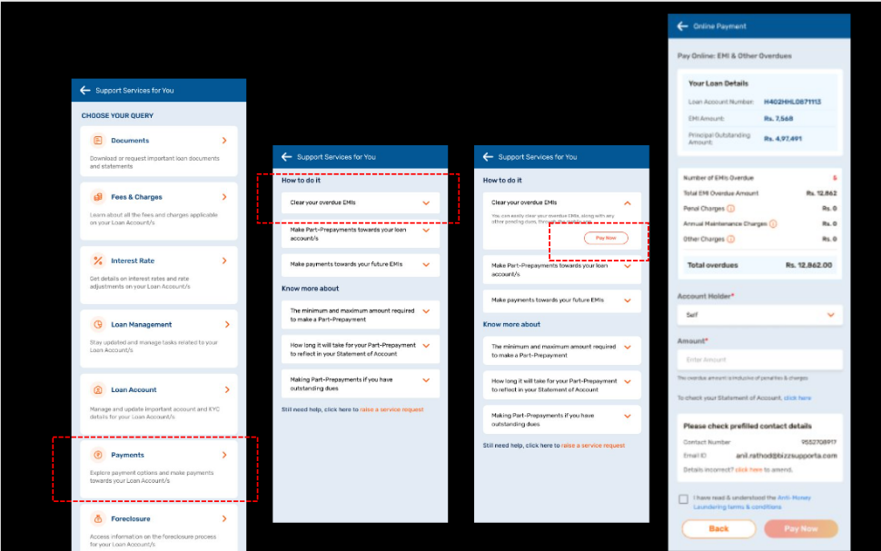

c) Once the user selects their query bucket (please update as the Figma), they should be redirected to its specific page

d) The next screen has three actionable choices: **‘How to?’**, **‘Know more ’** and ‘**Still need help? Click here to raise a service request’**

e) Component behavior:

* When the user clicks on any of the cards under ‘How to? ’section, the card should open

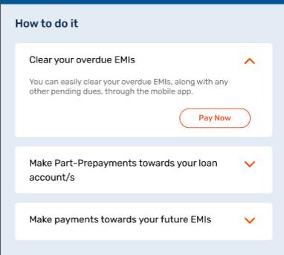

* If the user then clicks on the CTA provided in the card, they should be redirected to the subsequent action page

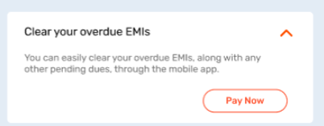

* When the user clicks on any of the cards under ‘Know more’ section, the card should open to show the content. To close the card, the user should click the downwards arrow

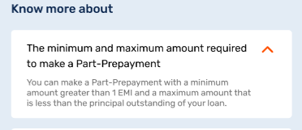

* If the user wants to raise a service request, they will click on ‘Still need help? Click here to raise a service request’, which will redirect to a short form, with two adapts. Note that this text only appears hyperlinked, however, the user simply has to be redirected to the ‘Service Request’ screen:

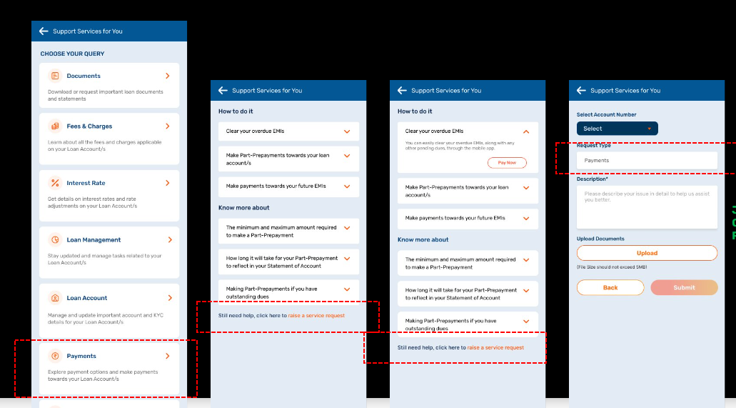

STATE 1: If the user has only one LAN, the LAN selection should be pre-populated

STATE 2: If the user has two LANs, the ‘Select Account Number’ dropdown should be empty for the user to select

* Inside the form, the **‘Request Type’** field should be pre-populated with the origin query bucket
* Inside the form, the CTA button **‘Submit**’ should not be enabled till all mandatory fields have not been filled in. This should include the following fields: **‘Select Loan Account Number’** and **‘Description’**

Note that **‘Upload Documents’** is NOT a mandatory field

* Once the user’s journey of raising the request is completed, they should be shown the thank you screen, as shown in the Figma

# STANDARDISATION OF COMMON ELEMENTS

This section outlines all changes and optimisations made to elements commonly used across all journeys and builds within the app. This will ensure that the UI, content, and behavior are standardized across the asset.

**Note: We have not received any screens for common elements such as ‘Alerts’ and ‘Notifications’.**

# Pop-ups

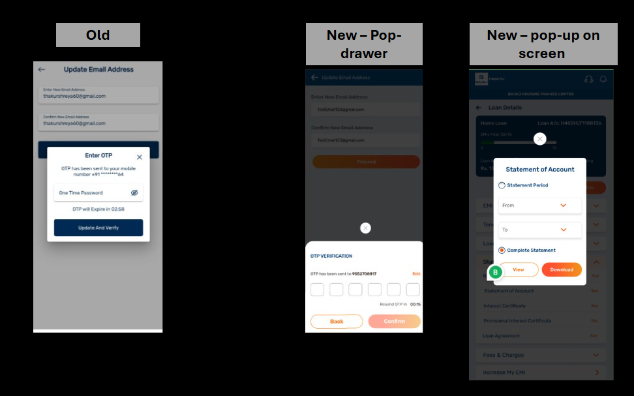

The ‘pop-up’ element has been standardised across the asset, with only two exceptions:

1. UI change: Earlier, all ‘pop-ups' appeared on top of the screens; now, all pop-ups should appear as the bottom drawer on the screen
2. UI exception: The only two exceptions to this are the pop-ups that occur in all the **‘Statements & Documents’** journeys (via ***Docked Footer, Quick Links, and the Loan Details page***) and the ‘**Select Loan Account’** pop-ups and the subsequent pop-ups that occur in the same journey:

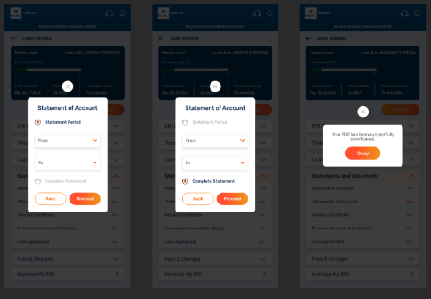

1. Pop-up behavior: As such, there should be **no change** in the existing behavior:

* OTP drawers retain dynamic CTAs
* OTP drawers should also have the ‘03:00 to 00:00’ timer
* **‘To and From’** pop-ups should retain their calendar selection behavior
* All T&C pop-ups, AML pop-ups, should still have their respective CTAs &

### 9.A. Pop-up > OTP Pop-up

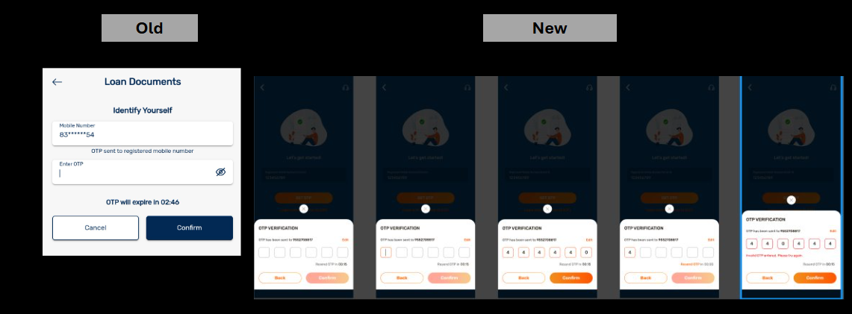

1. All OTP pop-ups should only have **one uniform title: OTP VERIFICATION**
2. **Remove all additional titles,** such as ‘Loan Documents, identify yourself,’ etc. This list is not exhaustive; please update as per Figma
3. The sentence **‘OTP has been sent to XXXXXXXXXX’** above the OTP field; please note that the mobile number should be fetched from the back end, and should be the user’s registered mobile number, which is mapped in our records
4. UI Change: Earlier, the OTP field was a flat block-y field; however, now it has been updated to a 6-digit boxy element
5. Component behavior: Whenever a digit is filled into the box, the box should have an **orange outline;** please update as per the Figma
6. Component behavior: If there is an error in the inserted OTP, the boxes should then be **outlined in red; again,** please update as per Figma
7. Component behavior: If there is an error in the inserted OTP, an error message should be shown under the OTP field in red. All scenarios have been mapped in the ‘Login’ section of the BRD; please update content and UI from Figma and the section

# Key Component Highlights

This section focuses on the treatments applied to components, such as tiles & fields to enhance user attention and engagement.

1. UI for errors: Fields with errors should be outlined in r**ed upon validation** to clearly highlight them to the user:

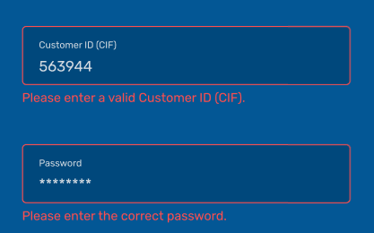

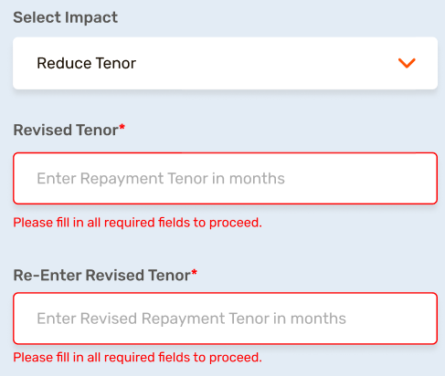

1. UI for tile selection in the Docked Footer: If the user selects a tile from a tray, the tile should be **highlighted with a light orange tinge, and an orange outline to indicate selection:**

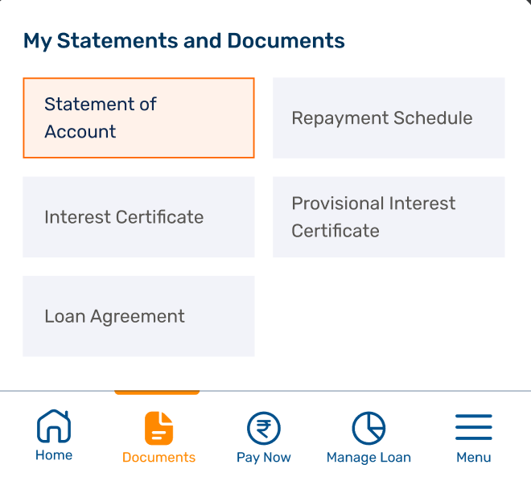

1. UI for dropdown selection: When a user selects an option from a dropdown, the selected option should be highlighted with a l**ight orange colour to indicate selection:**

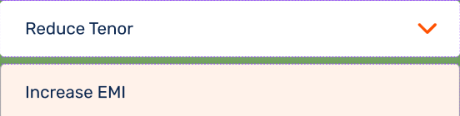

# Load Time

This section outlines the appropriate icon or screen to display during instances where a loading state needs to be conveyed:

### 11.A. Load Time > Screen

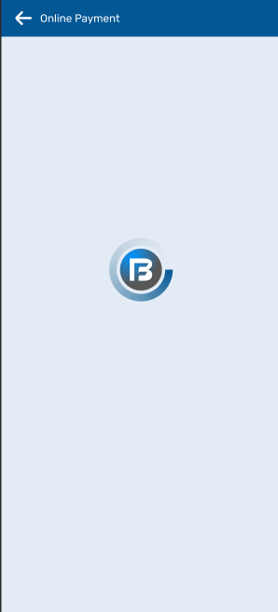

1. UI behavior: Whenever a **‘load time**’ occurs between two screens—i.e., during a transition in the user journey—the specified loading screen should be displayed.

### 11.A. Load Time > Icon treatment for particulars in-screen

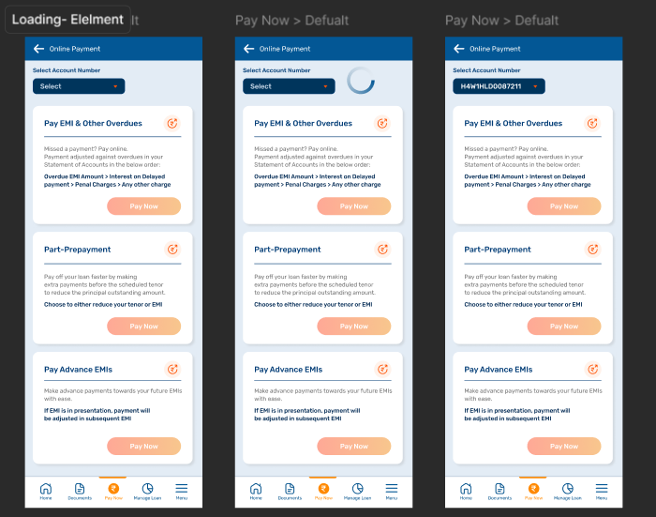

1. UI behavior: When the **‘load time’** occurs within a screen—such as during the selection of a single element (e.g., **LAN selection**, where APIs may take time to load)—the **‘load time’ icon should be positioned adjacent to the element causing the delay.** This ensures users are aware of the specific process that is loading.

**Note: Dheeraj/Vijay to provide detailed instances of ‘load times,’ enabling us to design additional treatments tailored to specific journeys and scenarios.**